*INST737: Introduction to Data Science*

***Project Milestone-2: Report***

Instructor: Dr. Vanessa Frias-Martinez

Team5 : Sadaf Nasir Davre, Tanya Gupta, Ushasri Bhogaraju

Term : Fall ’23

*Milestone1 Summary* : We started with a [financial dataset of Fannie Mae](https://datadynamics.fanniemae.com/data-dynamics/#/downloadLoanData/Single-FamilyDataset) with over 1M rows and 108 variables and a layout file of 108 observations and 10 variables, and performed Data transformation, Data cleaning and Software engineering steps. We identified our focus variables and performed statistical analysis on them. We identified columns with Null values and removed them. We corrected data types and visualized and examined outliers.

Incorporating feedback from Instructor and Peer reviews from Milestone 1:

1. Exploring new variables that may have more influence on our outcome variable, Original interest rate of the Loan : This input was from peer review. We added new variables after ascertaining the lack of predictive power of existing variables after attempting linear regression. Therefore, the entire process of data cleaning, removing null and NA values, removing outliers and performing linear regression was done twice, once with an existing set of IVs and again after adding new IVs.(Since the dataset has changed in dimensions )
2. Detailed explanation of variables :

| Our variables and what they mean | | | |
| --- | --- | --- | --- |
| S.No | Variable Name | Data type | Description |
| 1 | Original.Interest.Rate | numeric | The original interest rate on a mortgage loan as identified in the original mortgage note. It is a numeric continuous variable. This was the outcome variable we used to train models for linear regression, and Random Forests |
| 2 | Original.UPB | numeric | The dollar amount of the loan as stated on the note at the time the loan was originated. |
| 3 | Original.Loan.to.Value.Ratio..LTV. | numeric | The ratio, expressed as a percentage, obtained by dividing the amount of the loan at origination by the value of the Property |
| 4 | Original.Combined.Loan.to.Value.Ratio..CLTV. | numeric | The ratio, expressed as a percentage, obtained by dividing the amount of all known outstanding loans at origination by the value of the property. |
| 5 | Number.of.Borrowers | numeric | The number of individuals obligated to repay the mortgage loan. |
| 6 | Debt.To.Income..DTI. | numeric | The ratio obtained by dividing the total monthly debt expense by the total monthly income of the borrower at the time the loan was originated. |
| 7 | Borrower.Credit.Score.at.Origination | numeric | A numerical value used by the financial services industry to evaluate the quality of borrower’s credit. Credit scores are typically based on a proprietary statistical model that is developed for use by credit data repositories. These credit repositories apply the model to borrower credit information to arrive at a credit score. When this term is used by Fannie Mae, it is referring to the "Classic" FICO score developed by Fair Isaac Corporation. |
| 8 | Number.of.Units | numeric | The number of units comprising the related mortgaged property (one, two, three, or four). |
| 9 | Property.State | chr | Property Unpaid Balance. This represents the quantum of loan sanctioned to the Bprrower |
| 10 | Seller.Name | chr | The name of the entity that delivered the mortgage loan to Fannie Mae. |
| 11 | Loan.Purpose | chr | An indicator that denotes whether the mortgage loan is either a refinance mortgage or a purchase money mortgage. Purpose may be the purchase of a new property or refinance of an existing lien (with cash out or with no cash out). |
| 12 | Occupancy.Status | chr | A categorical variable with 3 classes namely "P", "S" and "I". The classification describes the property occupancy status at the time the loan was originated.This variable describes whether the property being purchased with the loan, is the Primary residence of the borrower, Secondary Home or for investment. This is the variable we used as outcome variable for training Logistic Regression, Naïve Bayes and Decision Tree models. |
| 13 | Property.Type | chr | An indicator that denotes whether the property type secured by the mortgage loan is a condominium, co-operative, planned urban development (PUD), manufactured home, or single-family home. |
| 14 | bondRate | numeric | 10- year Treasury Bond Yield Rate |
| 15 | fedFundsRate | numeric | The ‘Fed funds rate’ is the interest rate at which lending institutions lend or borrow funds from other institutions overnight, on an uncollateralized basis |
| 16 | benchMarkMortgageRate | numeric | Benchmark average rate of 30 year fixed rate mortgages in the United States |

*Milestone 2 Report :*

*Phase -1 cleaning and removing outliers (before performing linear regression and deciding to infuse new variables)*

*Cleaning our Dataset by removing outliers from the numerical values.*

Our dataset had 8 Numerical, 3 Categorical and 2 Nominal variables as described above. These are all variables that describe various parameters of the loans from the Fannie Mae dataset. Our primary research question was to understand how these variables were helping in predicting the ‘Original Interest Rate’, also called the ‘Note Rate’ at the time of sanction of the loan. The presence of Boundary Outliers in these variables was detected using Histograms and summary statistics in Milestone-1 analysis. In this phase, we used BoxPlots to visualize and the IQR method to remove Outliers.

The IQR method involves determining the spread of the middle 50% of the data. The 1st Quantile is the 25th percentile of the data and represents the lower boundary of the middle 50% of the data. The 3rd Quantile is the 75th percentile of the data and represents the upper bound of 50% of the data. The InterQuartile Range is the difference between these two Quantiles. The lower bound is given by the formula Q1 - 1.5*IQR and the upper bound by Q3 + 1.5*IQR. Any datapoint that falls below the lower bound and above the upper bound can be deemed an outlier. We applied this principle to all our Numerical variables and removed the outliers by subsetting the middle 50% of the data.

*Original Interest Rate Variable: T*he lower bound detected using the IQR method is 3.655 and the upper bound is 8.407. The interest rate values below and above these bounds may be data entry errors or special cases of loans which are not expected to be useful for prediction of the normal case of the dependent variable. We retained rows that fall between the lower and upper bounds and the dimensions of the dataset after this step are: 270,153 observations of 13 variables.

The datasets generated after eliminating outliers in one variable were used as input dataset for the next variable. Thus outliers were eliminated from all the variables and a final dataset named "Cleaned_FM2022Q4.csv" with dimensions 248,356 observations of 13 variables was saved. This dataset is being split into Test and Training datasets for use with our Prediction Model. .

The Visualizations using BoxPlots are :

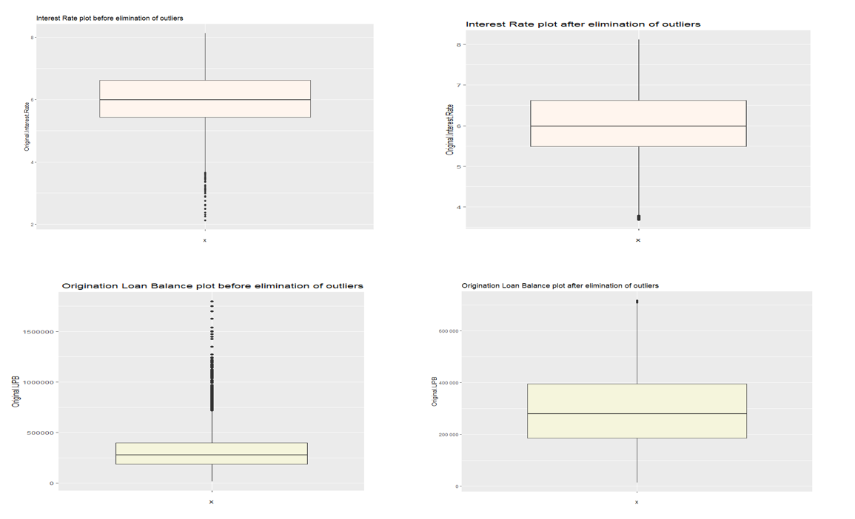

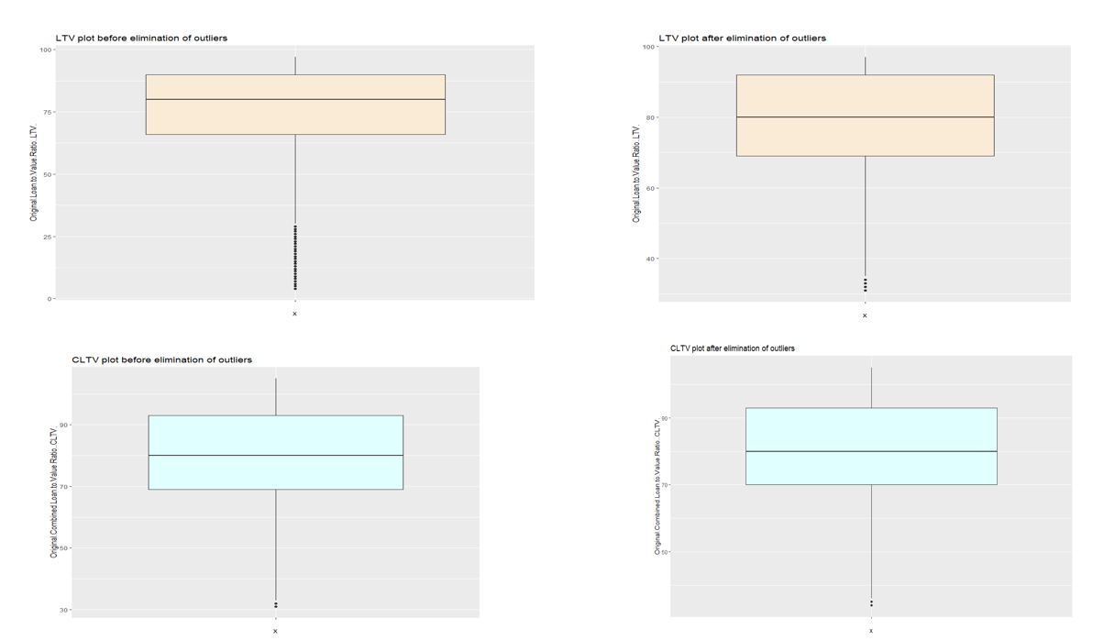

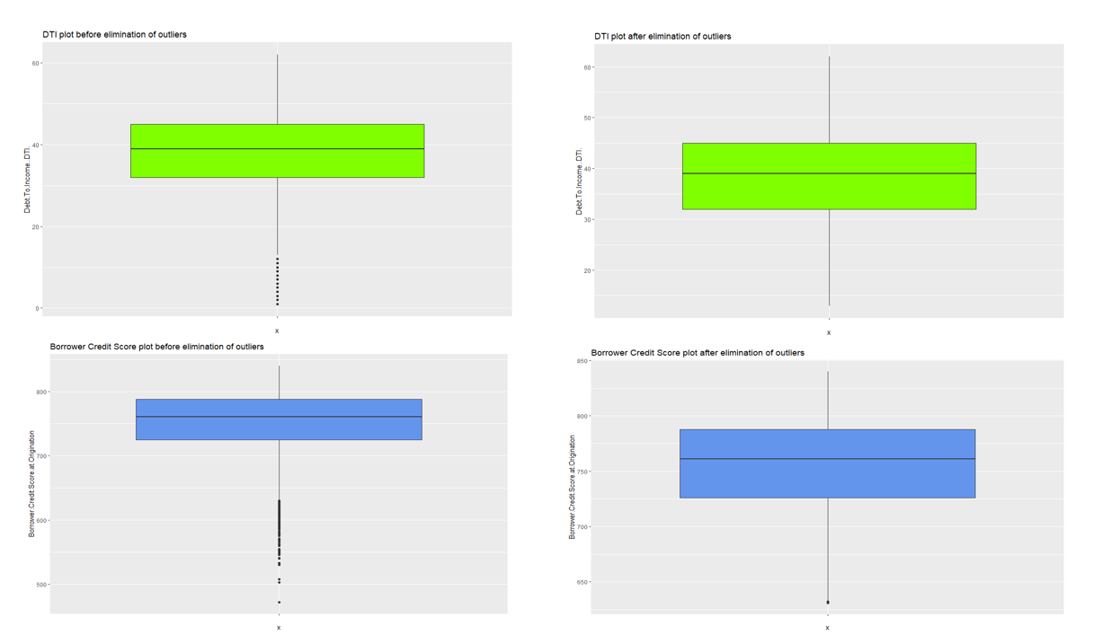

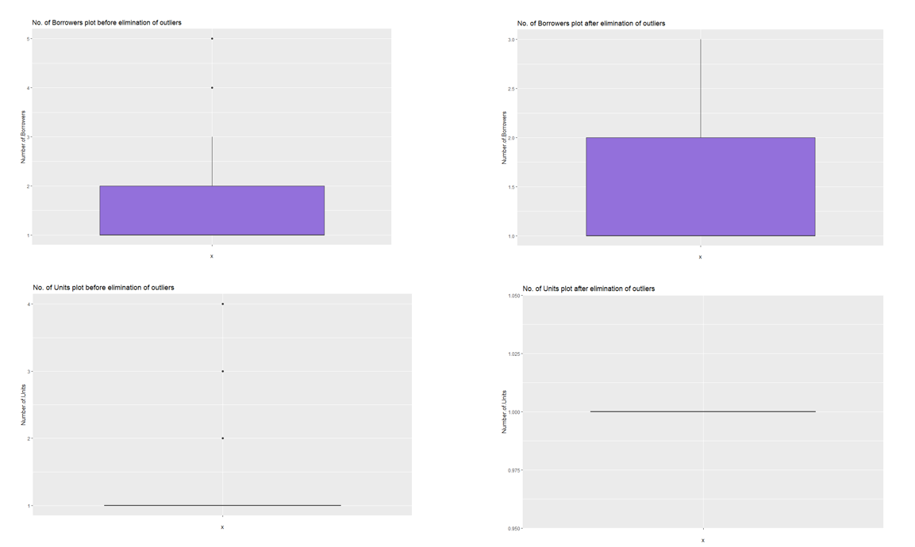

Table listing the number of outliers in each of the numeric variables and the corresponding Data Loss:

| Variable Name | No of Obs with Outliers | No of Obs without Outliers | Data Loss ( No. of Rows) % |
| --- | --- | --- | --- |
| Original.Interest.Rate | 270993 | 270153 | 840 (0.3%) |
| Original.UPB | 270153 | 267070 | 3083(1.1%) |
| Original.Loan.to.Value.Ratio..LTV. | 267070 | 258261 | 8809(3.2%) |
| Original.Combined.Loan.to.Value.Ratio..CLTV. | 258261 | 255948 | 2313(0.9%) |
| Debt.To.Income..DTI. | 255948 | 254262 | 1686(0.7%) |
| Borrower.Credit.Score.at.Origination | 254262 | 252632 | 1630(0.6%) |
| Number.of.Borrowers | 252632 | 252145 | 487(0.2%) |
| Number.of.Units | 252145 | 248356 | 3789(1.5%) |

**Question 1. Linear Regressions. [15 points] SADAF**

Divide your dataset into training and testing sets as we have seen in class and report:

*Splitting Data into Training and Test Datasets:*

After elimination of outliers, we have our Cleaned dataset with the dimensions of 248,356 observations of 13 variables. We chose to split this dataset into Test and Training datasets with 25% and 75% of observations in the dataset respectively. To ensure random selection of rows, so that no bias enters either the training or the test datasets, we used R code to divide the row numbers in our cleaned dataset by 4 and if the remainder is zero, that row gets added to the test set. We thus made our “Training_FM2022Q4.csv” dataset with 186,267 observations of 13 variables and “Test_FM2022Q4.csv” dataset with 62,089 observations of 13 variables.

**a [5pts].** Linear Regression Parameters (show plots where applicable)

For each independent variable in your model, compute a linear regression with respect to the dependent feature and report:

- What is the intercept?

- What is the coefficient?

- Is it a predictive feature?

We computed the linear models with each IV and the DV. This is a tabular representation of the main summary statistics of each of the models. We also visualized the Linear regression line using plots. At the end, we provide a summary table with the statistics of the models. The interpretation of intercept value is not done separately. Intercept represents the value of DV when the value of all IVs in the linear model is equal to zero. It is the baseline value of the DV given IV = 0

*1.Original.UPB and Original.Interest Rate*

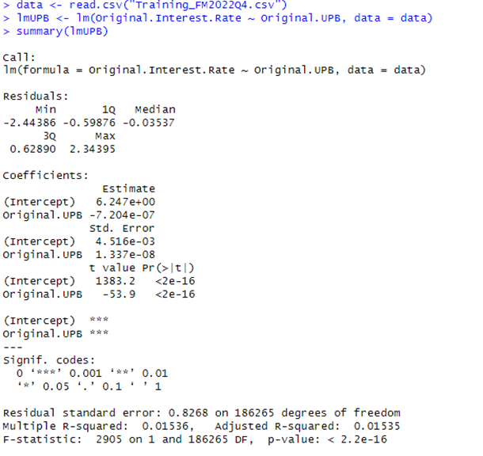

*Plot of the Linear Regression line*

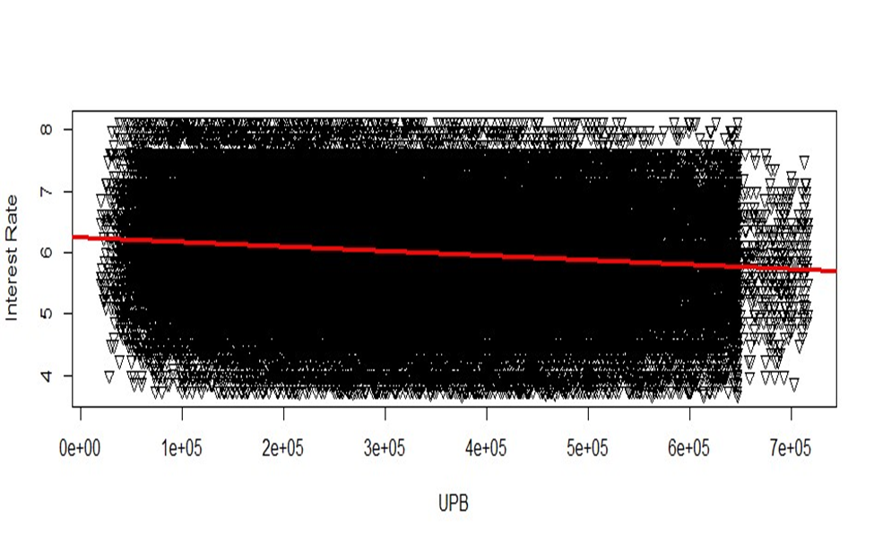

Summary : The negative coefficient and the highly significant t-value suggest that there is a statistically significant negative relationship between the Original.UPB predictor variable and the Original.Interest.Rate outcome variable. However, the magnitude of the coefficient is extremely small, indicating that while there is a statistically significant relationship, the practical impact on one-unit change in Original.UPB on Original.Interest.Rate is very minimal.

| Independent Variable Name | What is the intercept? | What is the coefficient? (Slope) | Is it a Predictive Feature |
| --- | --- | --- | --- |
| Original.UPB  The model’s  Null Hypothesis: The correlation between the independent variable Original UPB and dependent variable Original Interest Rate is ‘0’ (the value of the predictor variable ‘Original UPB’ has no effect on the value of the outcome variable) | Intercept value estimated by the model is 6.247e+00  The Standard error associated with this estimate is 4.516e-03 which is quite low.  The t value for the intercept is 1383.2 which is large and the associated p-value is <2e-16, which is statistically highly significant | The magnitude of the coefficient estimated by the linear regression model is -7.204e-07.  1. The very small value 7.204e-07 indicates that one-unit change in the independent variable results in a very small change in the value of the dependent variable.  2. The relationship between the variables is inverse. One unit increase in UPB results in a very small decrease in interest rate.  The standard error associated with this estimate is 1.337e-08 which is very low.  The t-statistic is -53.09 which is large and the associated p-value <2e-16 indicates that this value is statistically significant. | Because the large value of F-statistic of the model, (2905 on 1 with 186265 degrees of freedom) and the associated small p-value < 2.2e-16, indicate that the explained variation of the model is significantly larger than what would be expected by chance. This suggests that the model is statistically significant in explaining the variation in the dependent variable and the Null can therefore be rejected.  But the R squared value is 0.01536 which is low and the goodness of fit of the model between these two variables is small.  We can say that UPB is therefore a predictive feature but with a low predictive power. The plot confirms the same. |

2. Linear Model for LTV IV and DV Original Interest Rate

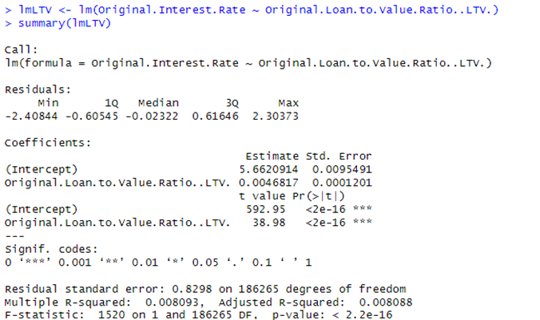

Plot of the regression line for LTV variable

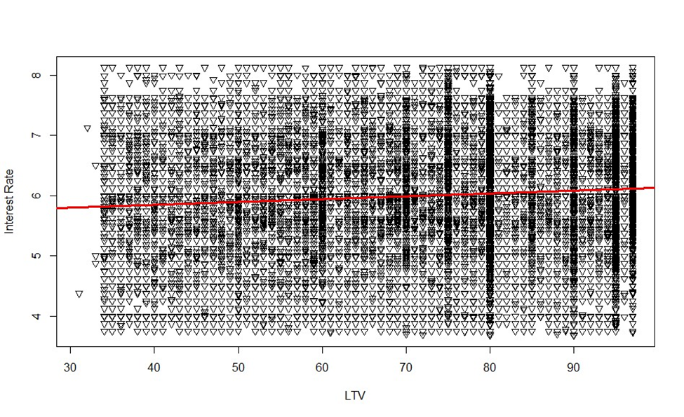

Interpretation:

| Independent Variable | What is the intercept? | What is the coefficient? (Slope) | Is it a Predictive Feature |
| --- | --- | --- | --- |
| LTV | 5.662.0914 | 0.0046817 and associated p val is <2e-16 which is statistically significant. | Yes. The F-statistic value of 1520 on1 with 186265 DF and p-value <2.2e-16 indicates that the variability in the model cannot be explained as due to chance. Since the size of the coefficient of the independent variable is small, the variability is minimal.  The R squared value is 0.008093 which is low and the goodness of fit of the model between these two variables is small. Hence we can say that this variable is a predictive feature but with a low predictive power. The plot confirms the same. |

3.Linear Model for CLTV and Interest Rate:

1. 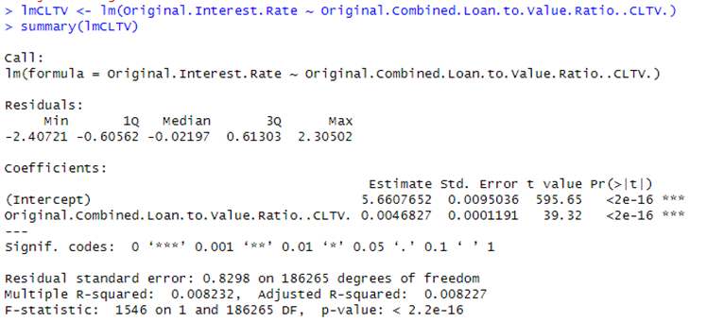

Plot of the regression line

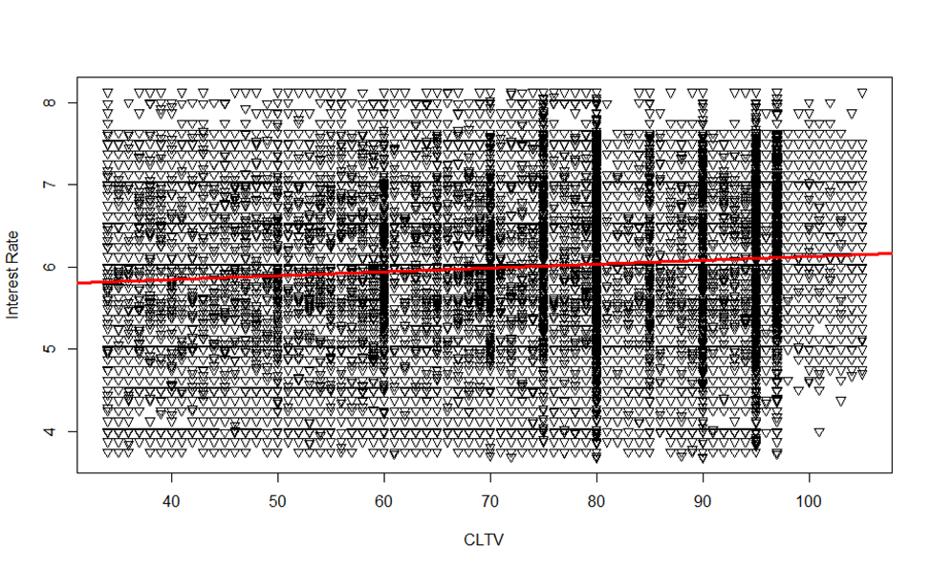

Interpretation

| Independent Variable | What is the intercept? | What is the coefficient? (Slope) | Is it a Predictive Feature |
| --- | --- | --- | --- |
| CLTV | 5.6607652 | 0.0046827 and associated p val is <2e-16 which is statistically significant. | Yes. The F-statistic value of 1546 on1 with 186265 DF and p-value <2.2e-16 indicates that the variability in the model cannot be explained as due to chance. Since the size of the coefficient of the independent variable is small, the variability is minimal.  But the R squared value again is 0.008232 which is low and the goodness of fit of the model between these two variables is small. Hence we can say that this variable is a predictive feature but with a low predictive power. The plot confirms the same. |

4.Linear Model for Borrowers variable

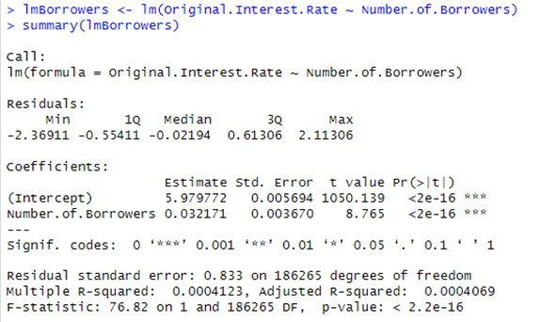

Plot of the regression Line

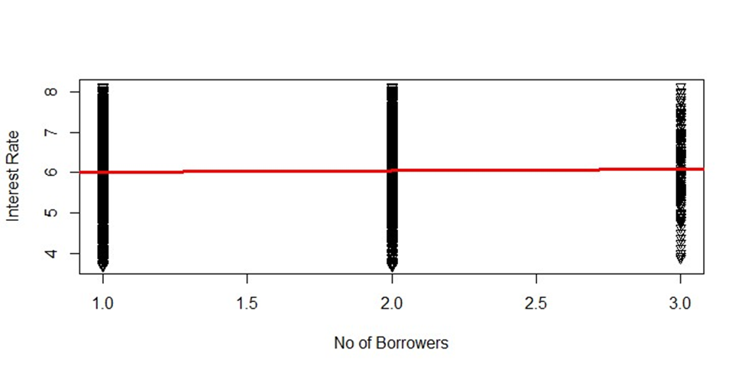

Interpretation

| Independent Variable | What is the intercept? | What is the coefficient? (Slope) | Is it a Predictive Feature |
| --- | --- | --- | --- |
| No of Borrowers | 5.979772 | 0.032171 and associated p val is <2e-16 which is statistically significant. | No The R squared value again is 0.0004123 which is very small and therefore goodness of fit of the model for the data between these two variables is minimal. We can say that this variable is not a predictive feature.  The Plot also confirms the same. |

5.Linear Model for DTI and OIR

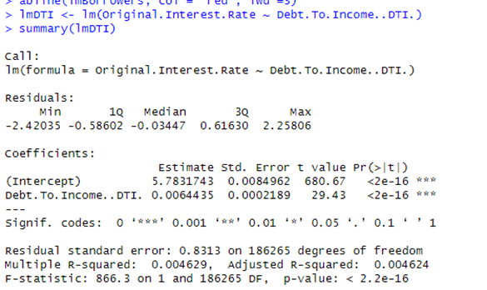

*Plotting the regression line*

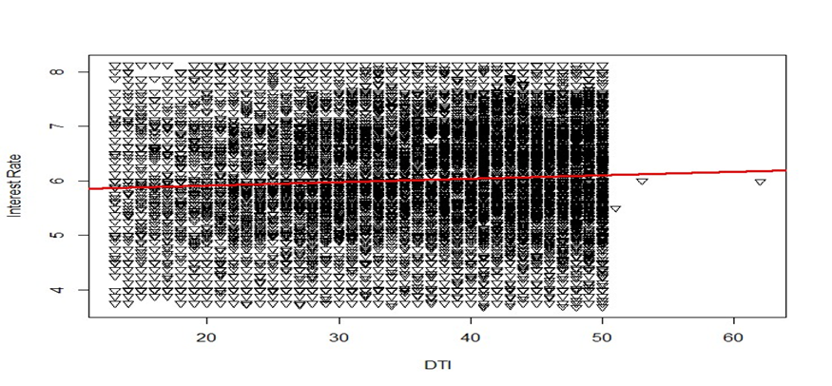

*Interpretation:*

| *Independent Variable* | *What is the intercept?* | *What is the coefficient? (Slope)* | *Is it a Predictive Feature* |
| --- | --- | --- | --- |
| *DTI* | *5.7831743* | *0.0064435* and associated p val is <2e-16 which is statistically significant. | *Yes. The F-statistic value of 866.3 on1 with 186265 DF and p-value <2.2e-16 indicates that the variability in the model cannot be explained as due to chance. But since the size of the coefficient of the independent variable is small, the variability is minimal.*  *But the R squared value again is 0.004629 which is low and the goodness of fit of the model for the data between these two variables is small. Hence, we can say that this variable is a predictive feature but with a low predictive power. The Plot confirms the same.* |

*6. Linear Model of Borrower Credit Score*

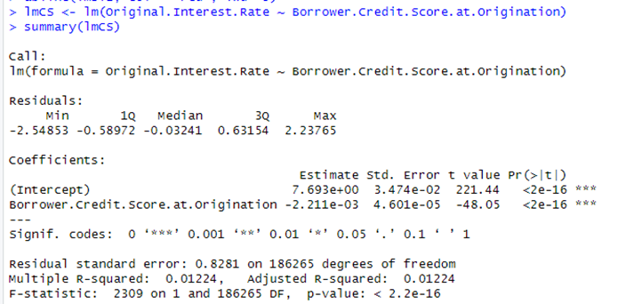

*Plotting the regression line*

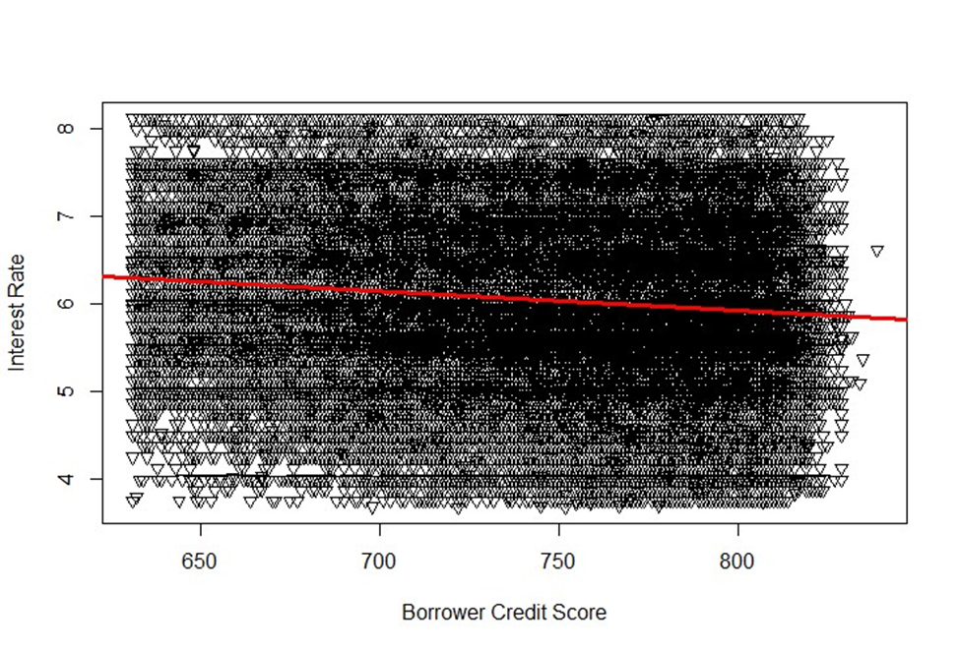

*Interpretation:*

| *Independent Variable* | *What is the intercept?* | *What is the coefficient? (Slope)* | *Is it a Predictive Feature* |
| --- | --- | --- | --- |
| *Borrower Credit Score* | *7.693e+00* | *-2.211e-03* and associated p val is <2e-16 which is statistically significant. | *Yes. The F-statistic value of 2309 on1 with 186265 DF and p-value <2.2e-16 indicates that the variability in the model cannot be explained as due to chance. But since the size of the coefficient of the independent variable is small, the variability is minimal. Also, the variables are inversely related, and the R squared value is 0.01224 which is low and therefore the goodness of fit of the model for the data between these two variables is small. Hence, we can say that this variable is a predictive feature but with a low predictive power. The Plot confirms the same.* |

7. Linear Model for No. of Units variable and OIR

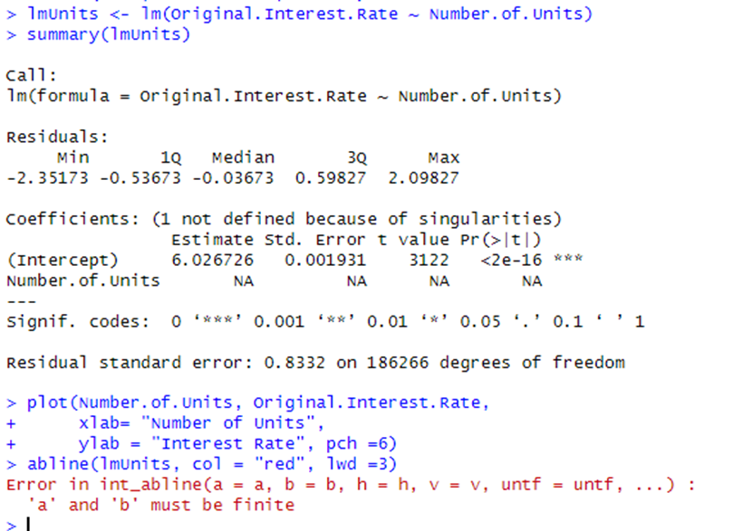

Plotting the variable also shows that the linear regression line cannot be visualized because of singularities in values of the IV ( there is only one value for this IV after removing outliers)

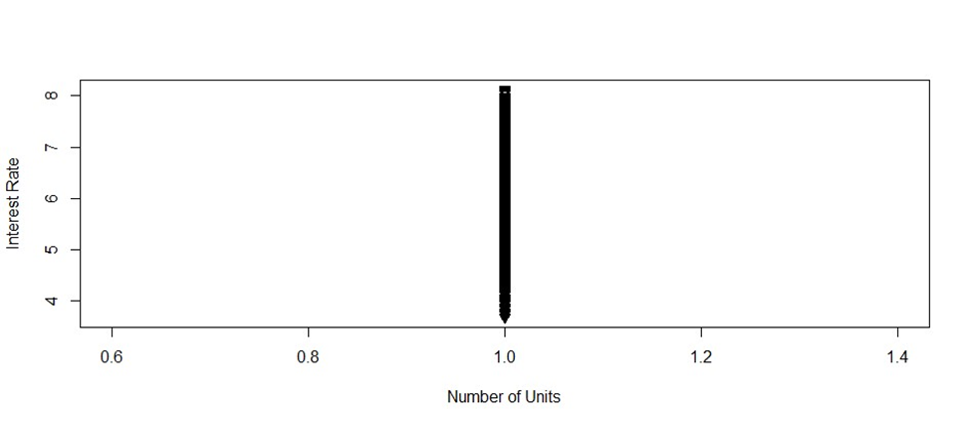

Interpretation:

| Independent Variable | What is the intercept? | What is the coefficient? (Slope) | Is it a Predictive Feature |
| --- | --- | --- | --- |
| No of Units | 6.026726 | NA. Not determinable due to singularities | No. All the interest rate values are converged at No. of Units =1. This indicates that while removing outliers, our data does not have variability for the number of units. The Plot confirms the same. Hence No of Units is not a predictive feature for our dependent variable. |

Linear models of Categorical and nominal variables:

To build linear models for our Categorical and nominal variables we used as.factor() function and built our models using R code

8.Linear Model for Property State Variable (Nominal)

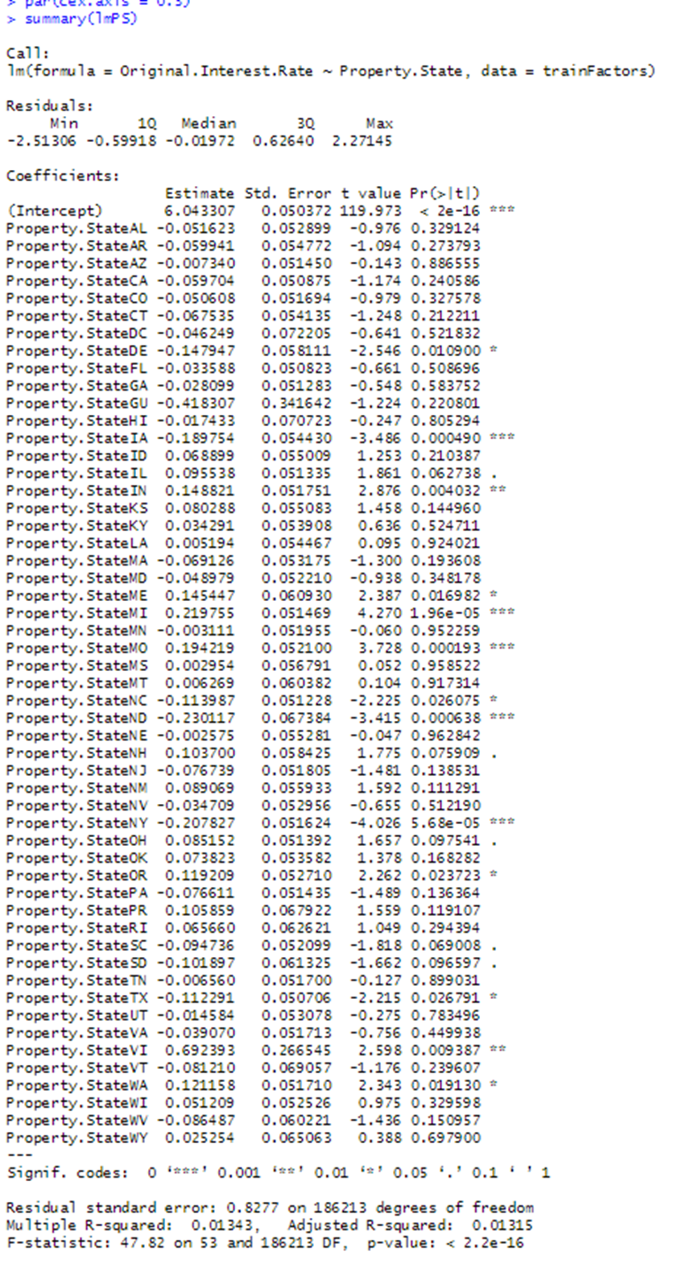

Plot of Property State against Interest Rates shows slight variations in mean interest rates for few states.

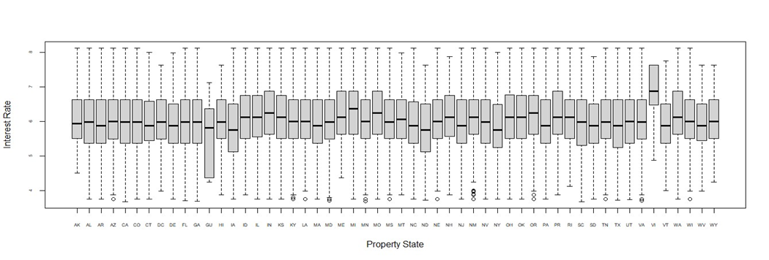

Interpretation:

| Independent Variable | What is the intercept? | What is the coefficient? (Slope) | Is it a Predictive Feature |
| --- | --- | --- | --- |
| Property State (Nominal) | 6.043307 | Coefficient magnitudes vary from 0.006 to 0.21. The statistical significance of these coefficients varies also.Coeffs of 14/55 states have low p-values.  For other states, the coefficients have little statistical significance. | Overall, No. The high F-statistic 47.82 and the low associated p-value indicate that the model as a whole is statistically significant in explaining variability in interest rate. However, the low R squared volumes 0.01343 indicate that the predictive power of Property State variable in predicting Original interest rate is not significant.    Based on the Plot we can say that some Property State levels such as VI and GU in the variable show variability with interest rate while some others show little variability |

9.Linear Model for Seller Name Variable (Nominal)

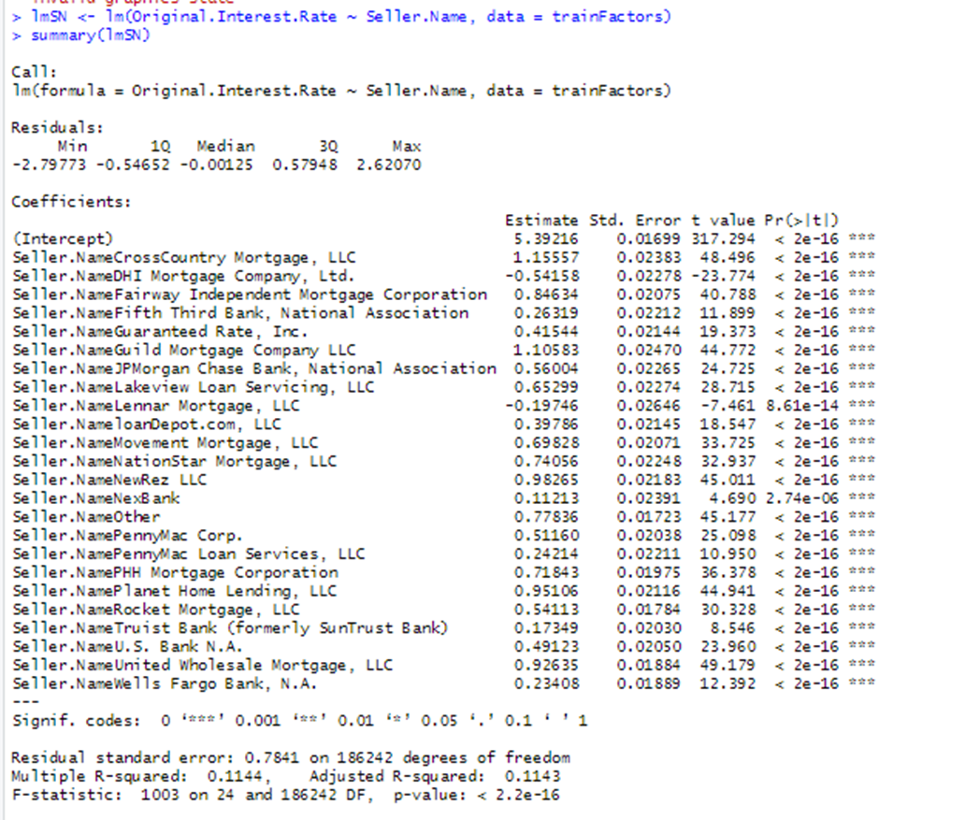

Plot:

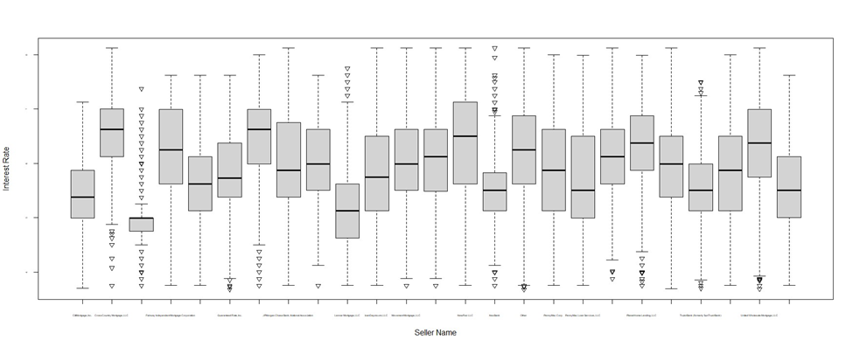

Interpretation:

| Independent Variable | What is the intercept? | What is the coefficient? (Slope) | Is it a Predictive Feature |
| --- | --- | --- | --- |
| Seller Name (Nominal) | 5.39216 | Coefficient values range from 0.23 to 1.15 and all the values are statistically highly significant.. | Yes, but Limited. The high F-statistic 1003 and the low associated p-value < 2.2e-16 indicate that the model as a whole is statistically significant in explaining variability in interest rate. The R squared volumes of 0.1144 indicate limited predictive power in explaining the variability in interest rate.  Based on the Plot we can say that many Seller Name levels in the variable show variability with interest rate while two levels do not show statistically significant variability |

10.Linear model loan purpose

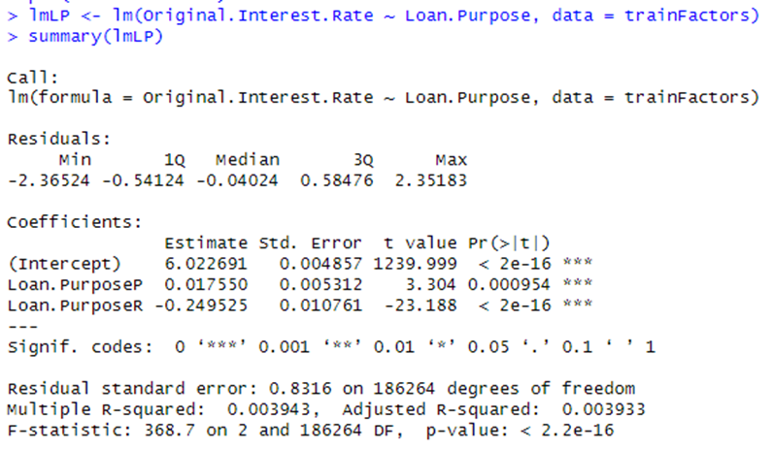

Plotting:

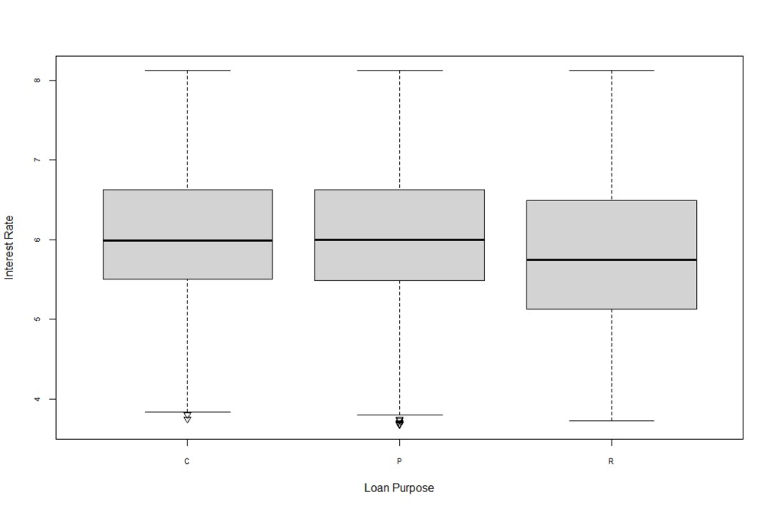

Interpretation:

| Independent Variable | What is the intercept? | What is the coefficient? (Slope) | Is it a Predictive Feature |
| --- | --- | --- | --- |
| Loan Purpose (Categorical) | 6.022691 | For Refinance it is -0.24955 and for Purchase it is 0.0175500. Both have significant p-values | As a whole, No. The high F-statistic 368.7 and the low associated p-value < 2.2e-16 indicate that the model as a whole is statistically significant in explaining variability in interest rate. However, the R squared volumes of 0.003943 indicate insignificant predictive power in explaining the variability in interest rate.  Based on the Plot we can say that ‘Refinance’ level in the Loan Purpose variable shows variability with interest rate while the other two levels do not show any variability |

11.Linear model with Occupancy Status as IV and OIR as DV

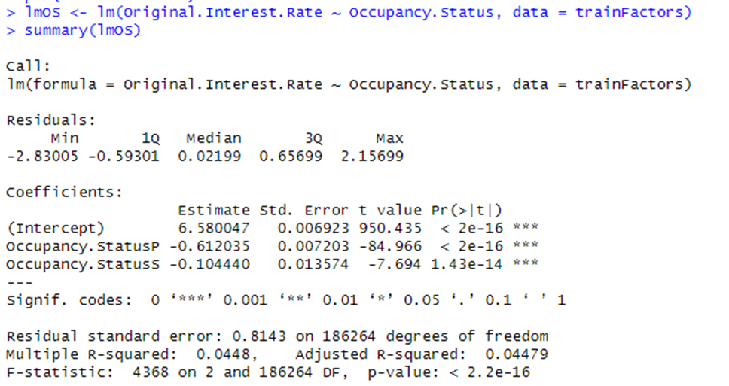

Plot:

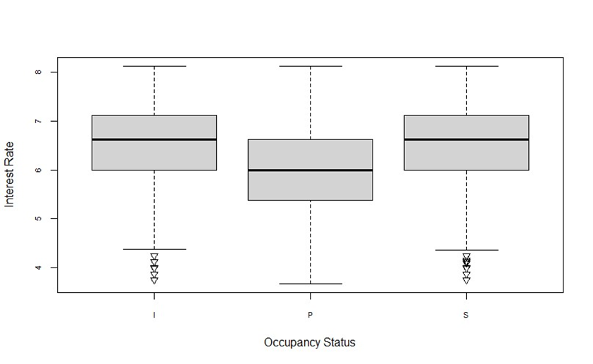

Interpretation:

| Independent Variable | What is the intercept? | What is the coefficient? (Slope) | Is it a Predictive Feature |
| --- | --- | --- | --- |
| Occupancy Status (Categorical) | 5.39216 | For Level  Primary Residence, P:-0.612035 with p-val <2e-16  S level it is -0.104440 with very low p -value | No. The high F-statistic 368.7 and the low associated p-value < 2.2e-16 indicate that the model as a whole is statistically significant in explaining variability in interest rate. However, the R squared volumes of 0.03943 indicate insignificant predictive power in explaining the variability in interest rate.    Based on the Plot we can say that Primary Residence level in the Occupancy Status variable shows variability with interest rate while Investor and Secondary Home do not show much variability |

11.Linear Model for Property Type variable

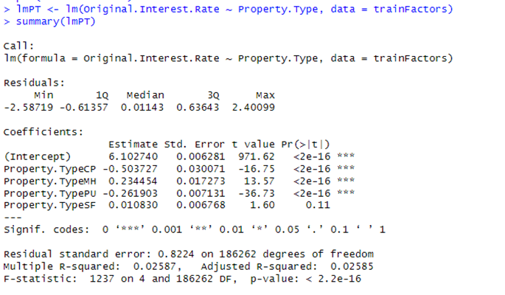

Plot

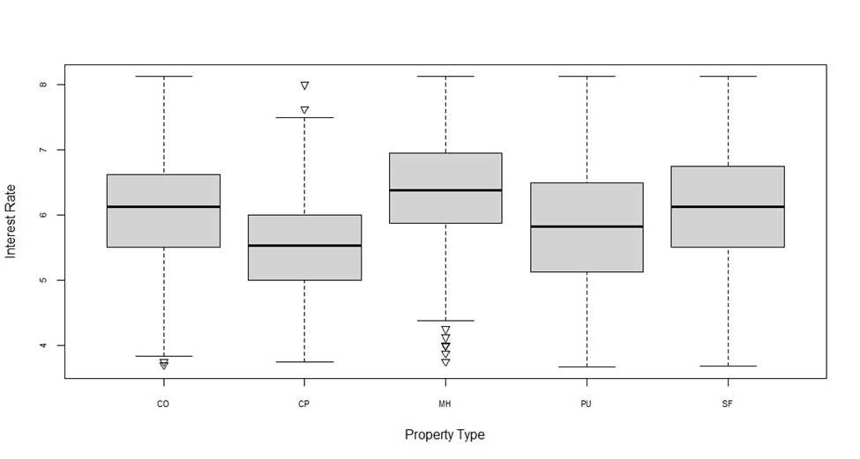

Interpretation:

| Independent Variable | What is the intercept? | What is the coefficient? (Slope) | Is it a Predictive Feature |
| --- | --- | --- | --- |
| Property Type (Categorical) | 6.102740 | For Level  CP:-0.503727  MH:0.234454  PU:-0.261903  SF: 0.010830 of these CP, MH and PU levels have low p-values and therefore are statistically significant | No. The high F-statistic 368.7 and the low associated p-value < 2.2e-16 indicate that the model as a whole is statistically significant in explaining variability in interest rate. However, the R squared volumes of 0.03943 indicate insignificant predictive power in explaining the variability in interest rate.    Based on the Plot we can say that except for SF level of the Property Type variable, remaining levels show statistically significant coefficient values, but the values are small. |

- Which are the most predictive features according to the training data?

We summarize hereunder the predictive power of all the IVs assessed by building linear models individually with the DV

| Milestone-2 Analysis : Decision if whether the variable is a predictive feature using Linear Regression Model for further analysis | | | | | |
| --- | --- | --- | --- | --- | --- |
| S.No | Linear Model on training dataset Built between | Coefficient of IV | p-value | Multiple R-Squared | Is it a Predictive Feature |
| 1 | Original.UPB & OIR | -7.204e-07 | <2e-16 | 0.01536 | Statistically significant but weak predictive power |
| 2 | Origina LTV. & OIR | 0.0046817 | <2e-16 | 0.008093 | Statistically significant but very weak predictive power |
| 3 | Original CLTV. & OIR | 0.0046827 | <2e-16 | 0.008232 | Statistically significant but very weak predictive power |
| 4 | Number.of.Borrowers & OIR | 0.032171 | <2e-16 | 0.000412 | No. Though statistically significant overall the model is very weak predictive power |
| 5 | Debt.To.Income..DTI. & OIR | 0.0064435 | <2e-16 | 0.004629 | Statistically significant but very weak predictive power |
| 6 | Borrower.Credit.Score.at.OIR | -2.211e-03 | <2e-16 | 0.01224 | Statistically significant but very weak predictive power |
| 7 | Number.of.Units & OIR | No. After removal of outliers, this variable is left with only 1 value. |  |  |  |
| 8 | Property.State as Factor & OIR | vary from 0.006 to 0.21. | 14/55 levels have statistically significant coeffs | 0.01343 | Overall, No. Many levels are Statistically insignificant. |
| 9 | Seller.Name as Factor & OIR | range from 0.23 to 1.15 | all levels have statistically significant coeffs | 0.1144 | Stronger than other variables, statistically significant but weak predictive power |
| 10 | Loan.Purpose as Factor & OIR | For Refinance it is -0.24955 and for Purchase it is 0.0175500 | <2e-16 for one level and 0.000954 for another both significant | 0.003943 | No. Though statistically significant overall the model is very weak |
| 11 | Occupancy.Status as Factor & OIR | -0.612035 for Primary residence level, -0.104440 for S level | <2e-16 and 1.43e-14 | 0.0448 | Statistically significant but weak predictive power |
| 12 | Property.Type as Factor & OIR | CP:-0.503727  MH:0.234454  PU:-0.261903  SF: 0.010830 | <2e-16 | 0.02587 | Statistically significant but weak predictive power |

At this stage we understood that though few of our IVs have slightly better coefficient values that were statistically significant, the R-squared values of the models indicate they are not a good fit.

We list hereunder, variables with slightly better predictive power than others.

The most predictive features according to Linear Models built on Training Data are :

1. Original UPB

2. Borrower Credit Score at Origination

3. Seller Name

4. Occupancy Status

5. Property Type

- What are the residuals?

Residuals are the difference between the actual values of the dependent variable and the values predicted using our Linear Model. The residuals in a linear model can be found using the resid() function in R. Linear regressions and Predictions work under the assumption that the Residuals follow a normal distribution. Whether or not they follow a normal distribution can be tested using the qqnorm() and qqline() functions in R. When we plot the residual using qqnorm and add a line using qqline, if both of them are near, we can say that the residuals are following a Gaussian(normal) distribution. And the underlying assumptions of the linear models built are valid.

The following plots for residuals if each of the linear models discussed above, (for the dependent Original Interest Rate variable with each of the independent variables (7 numeric and 3 categorical and 2 nominal), follow approximate Gaussian distributions.

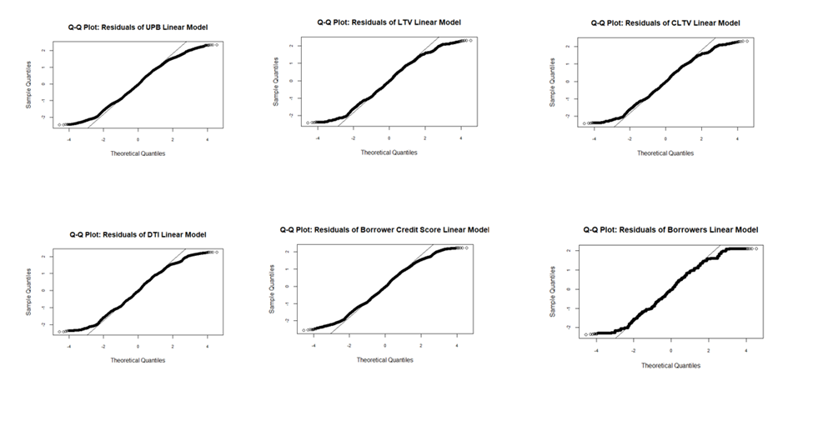

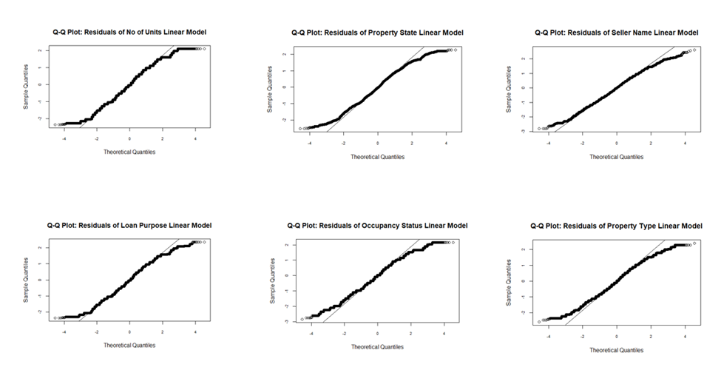

Is a linear regression applicable to your problem?

When we are using the lm() function in R, R finds the values of intercept and coefficient that best minimize the squared error. Based on the values we found for coefficients for different independent variables(slope) in our dataset and the statistical significance of the slope, as well as the R squared values for the models themselves, we can say that linear regression indeed is applicable to our problem. Linear regression thus far has revealed the predictive power of each independent variable and the different levels of categorical and nominal variables with respect to the dependent variable. Because of the results, we are able to identify variables without predictive power and as we move forward in our analysis, we will probably be only using those variables that have better predictive power.

- Use the trained model to predict your testing data. Show results together with confidence and prediction bands. Report prediction accuracy using (1) the correlation between the predicted and real values and (2) the mean square error between the two.

Using the lmCS model trained on training dataset to predict outcome variable values and comparing them with the actual data in the ‘Test’ dataset:

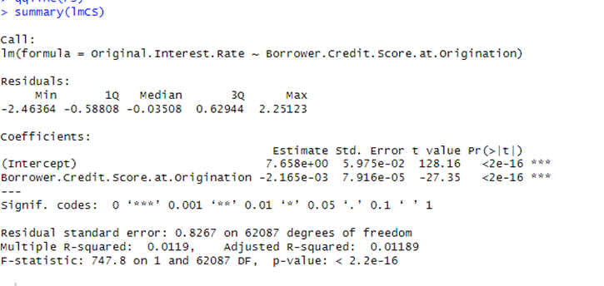

The distribution of the residuals for this model is approximately Gaussian, as is evident from this plot.

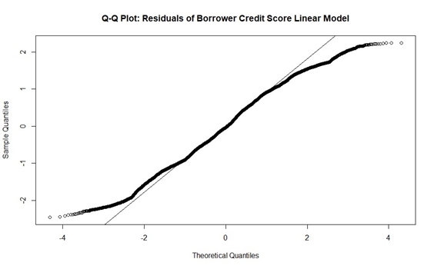

The Correlation coefficient and MSE for this model against predicted values are:

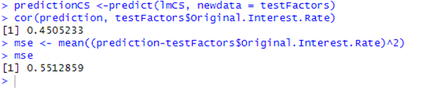

*Reporting accuracy of the model trained using entire Training data and testing on Test data:*

*Validity of the model and Correlation between predicted and actual values*: The distribution of the residuals is a Gaussian distribution; therefore the underlying assumption of the above linear model holds good. The Multiple R-Squared of our linear model is 0.0.0119 and F-statistic is 747.8 on 1 and 62087 DF, with a p-value <2.2e-16. The large F-statistic and the associated low p-value indicate that the results are not by chance. The R-squared value indicates the ‘goodness of fit’ of the model. Ideally if the value of R-squared is closer to 1, the model is considered a good fit. *We intend to improve our R-squared value by eliminating the variables without much predictive power, after multivariate analysis.* For now, since we have a valid linear model, we proceeded to predict values using test data and find the correlation between predicted and actual values. The correlation between the predicted and actual values of the dependent variable interest rate is 0.4505233 which is positive, indicating a positive linear relationship between predicted values of the Interest Rate variable and the actual values from Test data. The magnitude of 0.4505233 suggests that the relationship is moderate to strong according to [this](https://www.ncbi.nlm.nih.gov/pmc/articles/PMC6107969/) article.

The Mean squared error value represents the average squared difference between the predicted values and the actual values and therefore, lower MSE values indicate better convergence between predicted and actual values. In the present model, the MSE is 0.5512859, indicating that on average our model has relatively small squared errors.

Plot of the model with Prediction and Confidence bands.

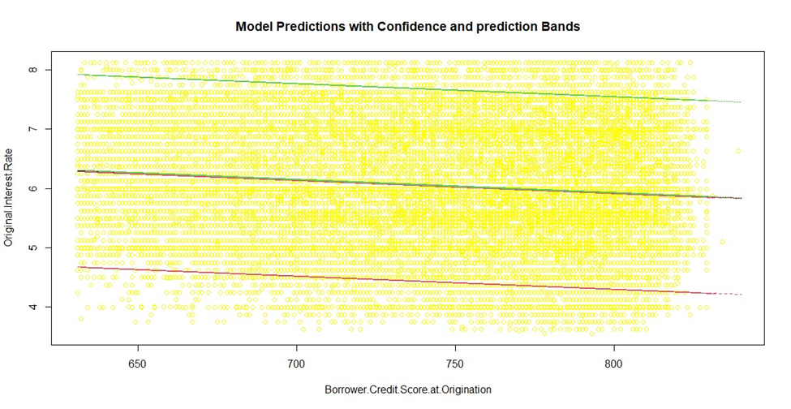

Interpretation:

A confidence band in regression analysis shows that the true regression line lies within these bands with a certain level of confidence. Prediction bands, on the other hand, account for variability in the data in addition to the uncertainty in the estimated regression coefficients. The Prediction bands indicate the space where the predicted values will lie. The confidence bands are just around the linear regression line in black in the plot. It is evident that the Prediction bands cover a wider area than the confidence bands from the above plot.

**b [4pts]** . Multivariate regressions

Show whether considering combinations of independent features improves the prediction results. Evaluate different combinations of features as applicable and report those that improve the results shown in question (a).

- Which are the coefficients for each feature?

When we performed multivariate analysis, we noticed that combinations of some IVs improved both the coefficients of variables and the R-squared values whereas some did not. We summarize hereunder, our findings.

| S.No | Linear Model on training dataset Built with a combination of | Coefficients of IVs | p-value | Multiple R-Squared | Improvement over previous linear models | Is it a Predictive Feature |
| --- | --- | --- | --- | --- | --- | --- |
| 1 | UPB + Credit Score | -6.690e-07  -2.008e -03 | 1.335e-08 | 0.02538 | No. The magnitudes (absolute values) of the coefficients in the combination model are actually smaller. The combination model R-squared values are slightly better than the values of the individual model but nowhere closer to 1. | No. Statistically significant but small coefficients and R-squared values indicating the model is not having an overall ‘goodness of fit’. *Independent models had better values for coefficients for these IVS, but this model has better R-squared* |
| 2 | Seller Name + Occupancy Status | Small Coefficient values <1 for all sellers except one. Occupancy status coefficients < 1 | <2e-16 for most coeff values | 0.1528 | Yes. The coefficients are slightly larger than the individual models but not significantly. Linear Models built with seller Name alone had a R-squared value of 0.1144 and with Occupancy status alone had 0.0448. This combination model is a better fit but the size of coefficients is still very small | No. Statistically significant but small coefficients and R-squared values indicating the model is not having an overall ‘goodness of fit’.  *Independent models had better values for coefficients for these IVS. But this model has better R-squared* |
| 3 | Seller Name + Property Type | Small Coefficient values <1 for all sellers except one. Property Type coefficients < 0.01 | <2e-16 most coeff values | 0.1144 | Model built with seller name variable alone had the same R-squared value and Property type alone had 0.02587 R-squared value. The combination model is at the same level of goodness of fit as that of Seller Name model | No.Statistically significant but small coefficients and R-squared values indicating the model is not having an overall ‘goodness of fit’.*Independent models had better values for coefficients for these IVS, but this model has better R-squared* |
| 4 | UPB+Credit Score+ Seller Name + Occupancy Status (4) | <0.1 | <2e-16 most coeff values | 0.1703 | This model has better R-squared value than individual models but small coefficients | No. Statistically significant but small coefficients and R-squared values indicating the model is not having an overall ‘goodness of fit’. *Independent models had better values for coefficients for these IVS, but this model has better R-squared* |
| 5 | UPB+Credit Score+ Seller Name + Occupancy Status + Property state + Property Type (6) | All coefficients in decimals | <2e-16 most coeff values | 0.1838 | The coefficients are all very small mostly <1 but statistically significant. Of all the models, this combination model has the best R-squared value.. But it is nowhere closer to 1 to surmise that this is the best ‘goodness of fit’ | No. Statistically significant but small coefficients and R-squared values indicating the model is not having an overall ‘goodness of fit’. *Independent models had better values for coefficients for these IVS, but this model has better R-squared* |

- Which are the most predictive features according to the training data?

Revisiting our IVs.

At this point, we understood that our independent variables have statistically significant but magnitude wise insignificant predictive power on our dependent variable. This was proven by testing both individual linear models and combination linear models for predictive power. At this point, we decided to formulate answers to our research questions using the research done thus far.

1. Can we accurately predict the ‘Interest Rate’ applied to a mortgage loan by a lending institution, using criterion such as the Quantum of loan, Loan-To-Value ratio, Debt-To-Income ratio, Loan Purpose, Number of Borrowers and Credit Score of the Borrower/s, using the Fannie Mae Acquisition and Performance 2022Q4 dataset?

*Answer : As per linear regression analysis, the models built around variables listed in this research question and few other variables like Seller Name, Occupancy status, Property State and Property type from the existing dataset have very small coefficients and R-squared values. These models do not offer sufficient predictive power to accurately predict our outcome variable ‘Interest Rate’. We therefore intend to infuse fresh IVs from datasets listed below to answer this question.*

2. Do all the borrower criteria such as the Quantum of loan, Loan-To-Value ratio, Debt-To-Income ratio, Loan Purpose, Number of Borrowers and Credit Score of the Borrower/s have equal influence over ‘Interest Rate’? If not, which criteria have more effect on Interest Rate?

*Answer: As per linear regression analysis, Quantum of Loan (UPB) and Borrower credit score have statistically significant but mild inverse effect on Interest rate variable, because of very small coefficients and R-squared values. The other variables offer still smaller predictive power and hence can be eliminated from further analysis. Of all the 12 variables in the current dataset, the ‘Seller Name’ variable had better predictive power than other variables.*

3. Do all lending institutions (presumed to be the ‘Seller’ in the dataset), evaluate the criterion variables similarly and fix the interest rate?

*Answer: As per linear regression analysis, Seller Name is the one variable in the existing dataset that seems to have a slightly better predictive power over interest rate than other variables, but the coefficients are still very small (<0.01 ) and the R-squared values of the models are also very small. Since this variable itself does not have good predictive power, we have determined that we cannot conclusively answer this question at this point in our analysis.*

We infused 3 variables namely ‘bondRate’, ‘fedFundsRate’ and ‘benchMarkMortgageRate’ from the datasets sourced from the following sites into the Final_FM_AP_FM2022Q4.csv dataset. (We added 3 independent variables and retained the earlier 12 independent focus variables along with the dependent variable.)

1. 10-year Treasury Bond rates from [*https://www.macrotrends.net/2016/10-year-treasury-bond-rate-yield-chart*](https://www.macrotrends.net/2016/10-year-treasury-bond-rate-yield-chart)

2. 30-year benchmark mortgage interest rates dataset: <https://www.macrotrends.net/2604/30-year-fixed-mortgage-rate-chart> : This is a benchmark chart that shows the average rates of 30 year fixed rate mortgages in the United States since 1971.

4. Fed funds Rate historical chart from: <https://www.macrotrends.net/2015/fed-funds-rate-historical-chart> : The ‘Fed funds rate’ is the interest rate at which lending institutions lend or borrow funds from other institutions overnight, on an uncollateralized basis. We absorbed it with a view that it represents the‘cost of funds’ for lending institutions.

We matched these variables on the ‘date’ column (common name in all three datasets) from these datasets and the Loan Origination Date column in our dataset. We renamed the ‘value’ variable (common name in all three datasets) in these datasets to reflect the name of the rate that is described in the details above. We then proceeded to filter out the variables that have not revealed any predictive power so far and rows with Null values. To save time, we used excel to perform vlookup on the Loan Origination Date column to add these 3 variables and retain variables that we have used so far in our research to verify if we can develop models with better predictive power.

*We now had to remove outliers, Nulls and NA values for all the 16 variables all over again!*

The dimensions of this dataset with various levels of transformations in captured in this table.

| Name of the dataset | No of observations | No of variables | Action Performed on this dataset |
| --- | --- | --- | --- |
| New_Variables_FM_AP_R_2022Q4.csv is the file created after adding 3 new independent variables to our Final Dataset matching on ‘Loan Origination Date’ | 271368 | 16 | Checking and removing Nulls from Borrower Credit Score and DTI variables to get 270993 observations of 16 variables. Glimpse data reveals 2 of the new variables, bondRate and fedFundsRate have ‘chr’ data type. View data reveals #NA values |
| data | 270993 | 16 | Changed datatype from’chr’ to ‘dbl’ for bondRate and fedFundsRate variables. Removed #NA values to get 184096 obs of 16 variables |
| NoNullsDataAsFactors.csv | 184096 | 16 | Removing outliers from Original Interest Rate variable |
| data | 183582 | 16 | Removing outliers from Original UPB variable |
| data | 181378 | 16 | Removing outliers from LTV variable |
| data | 176521 | 16 | Removing outliers from CLTV variable |
| data | 173966 | 16 | Removing outliers from No of Borrowers variable |
| data | 173625 | 16 | Removing outliers from No of Units variable |
| data | 170960 | 16 | Removing outliers from DTI variable |
| data | 169838 | 16 | Removing outliers from Credit Score variable |
| data | 168760 | 16 | Removed outliers from bondRate variable |
| data | 168312 | 16 | Removed outliers from fedFundsRate variable |
| data | 166778 | 16 | Removed outliers from benchMarkMortgageRate variable to get 156848 observations of 16 variables. Named this dataset New_FM2022Q4.csv |
| New_FM2022Q4.csv | 144130 | 16 | These are the dimensions of our final dataset. This will be split into Training and Test datasets for analysis |

We are only reproducing the box plots for the new variables here, with positions before and after removal of outliers. However, we have removed outliers for the entire set of variables in this new dataset and removed nulls and NA values.

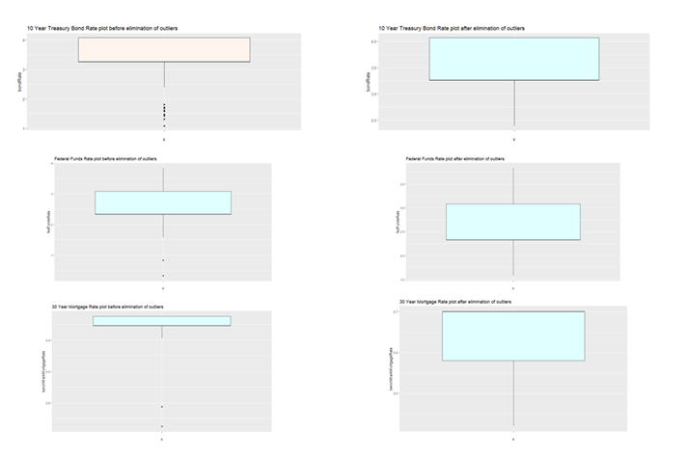

After removal of outliers, our dataset had 144130 observations of 16 variables which we named “New_FM2022Q4.csv”. We proceeded to split this dataset into test and training datasets by selecting every 4th row for the test dataset and remaining rows for training dataset using R. We named them “Test_FM2022Q4.csv” and “Training_FM2022Q4.csv”.

The dimensions of these datasets are:

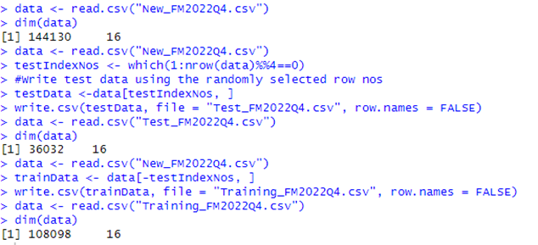

*Reporting Predictive power of Linear models built with each Independent variable and dependent variable.*

Using the New Training dataset, we built linear models with each of the independent variables and combinations of independent variables to ascertain if there is change in the predictive power of the models.

Summary of the Coefficients and R-squared values of Linear models built with each of the IV and DV from the new dataset.

| S.No | Linear Model on training dataset Built between | Coefficient of IV (Slope) | p-value | Multiple R-Squared | Remarks |
| --- | --- | --- | --- | --- | --- |
| 1 | Original Interest Rate |  |  |  |  |
| 2 | UPB & Original Interest Rate | -7.559e-07 | <2e-16, statistically highly significant | 0.01512 | Improvement in decimal value in magnitude of coefficient and R-squared value over previous model with the same IV, but not significant overall improvement in predictive power of the model. This model has No significant predictive power |
| 3 | LTV. & Original Interest Rate | 0.0046816 | <2e-16, statistically highly significant | 0.007157 | -do- |
| 4 | CLTV. & Original Interest Rate | 0.0046947 | <2e-16, statistically highly significant | 0.007288 | -do- |
| 5 | Number of Borrowers & Original Interest Rate | 0.041812 | <2e-16, statistically highly significant | 0.0006239 | -do- |
| 6 | DTI. & Original Interest Rate | 0.0067850 | <2e-16, statistically highly significant | 0.004573 | -do- |
| 7 | Borrower Credit Score & Original Interest Rate | -2.090e-03 | <2e-16, statistically highly significant | 0.009749 | Coefficient magnitude and R-squared values are slightly smaller than previous model with same variables. The model has No significant predictive power |
| 8 | Number of Units & Original Interest Rate | No. After removal of outliers, this variable is left with only 1 value. |  |  | Model cannot be trained. Singularity in in IV |
| 9 | Property State as Factor & Original Interest Rate | Maximum value is 0.53. 90% of the coefficients <0.2 | P-values range from 0.03 to 0.84. Not highly significant | 0.0136 | Slightly smaller coefficients and larger p-values with insignificantly small R-squared value than previous model with same IV. The model has No significant predictive power |
| 10 | Seller Name as Factor & Original Interest Rate | This variable has 25 levels, largest coefficient is 1.11, smallest is 0.02 | all < 2e-16 statistically highly significant | 0.1211 | Slightly better magnitudes of coefficients and R-squared than previous model. This IV is a weak predictive feature. |
| 11 | Loan Purpose as Factor & Original Interest Rate | -0.183567for Refinance other levels still smaller. | <2e-16, statistically highly significant | 0.002478 | Very small R-squared and coefficient values |
| 12 | Occupancy Status as Factor & Original Interest Rate | -0.626278 for Primary residence level, other levels much smaller | <2e-16, statistically highly significant | 0.04321 | -do- |
| 13 | Property Type as Factor & Original Interest Rate | Types CP, MH,PU have statistically significant coefficients, smaller than previous model | <2e-16, statistically highly significant | 0.02572 | -do- |
| *14* | *bondRate & Original Interest Rate* | *1.357337* | *<2e-16, statistically highly significant* | *0.3377* | *F-statistic5.512e+04 on 1 and a better magnitude of coefficient with a statistically significant p-value than other independent variables tested so far. Model has significant predictive power* |
| *15* | *fedFundsRate & Original Interest Rate* | *1.043833* | *<2e-16, statistically highly significant* | *0.3515* | *F-statistic: 5.859e+04 on 1 1 and a better magnitude of coefficient with a statistically significant p-value and R-squared values than previously tested independent variable. Model has good predictive power* |
| *16* | *benchMarkMortgageRate & Original Interest Rate* | *-5.60808* | *<2e-16, statistically highly significant* | *0.3212* | *F-statistic: 5.116e+04 on 1 and a much greater magnitude of coefficient that varies inversely with the dependent variable. The P-value associated with the coefficient value is also highly significant. Model has high predictive power* |

Clearly, the linear models trained on the new bondRate, fedFundsRate and benchMarkMortgageRate variables have coefficients of better magnitude with statistically highly significant p-values and mean R-squared values. The other models show lower levels of significance than those tested with previous dataset. Also, we have used those models to predict using testing data and reported prediction accuracy using correlation and mean squared error along with prediction and confidence bands. We are now proceeding to do the same for the linear models built with the new variables.

Validating the linear models with new variables : If the distributions of Residuals of the models follow a Gaussian distribution, we can say that the underlying assumption for the model is valid and therefore the model itself is valid. For each of the linear model with predictive power as described previously we proceeded to validate, predict using test data and report accuracy with correlation, mean square error & plotting with prediction and correlation bands as under:

1. Predicting with Linear Model bondRate IV and Original Interest Rate DV: This model has a prediction correlation coefficient of 0.5832867 & MSE of 0.5117943 as shown in the R command output below. The correlation coefficient indicates the correlation between predicted and actual values. A higher value indicates better correlation. Mean squared error on the other hand should be lower suggesting that the model’s predictions are closer to actual values, as it measures the average squared difference between actual values and predicted values of the DV . This linear model is therefore moderate in strength (<0.7) in predicting the outcome variable.

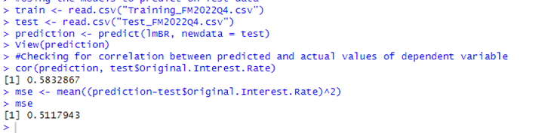

Plotting residuals: Distribution of Residuals of the model follow approximately a normal distribution but not exactly. . Maybe a linear regression is not the best approximation we can get to the model for this dataset.

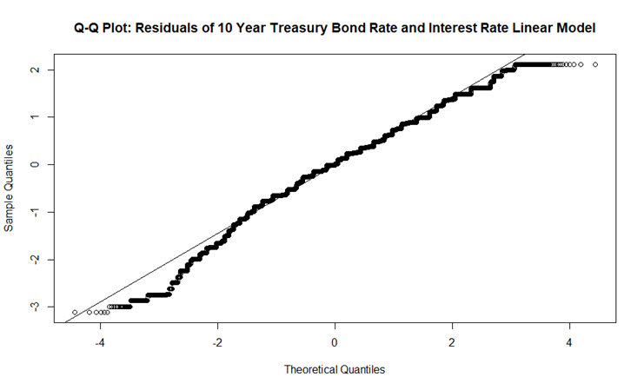

Plotting with prediction and correlation bands shows that all the predictions fall between 4.25% and 7% interest rate. The confidence bands in between them indicate that it can be said with 95% confidence level that the true regression line lies between these two bands

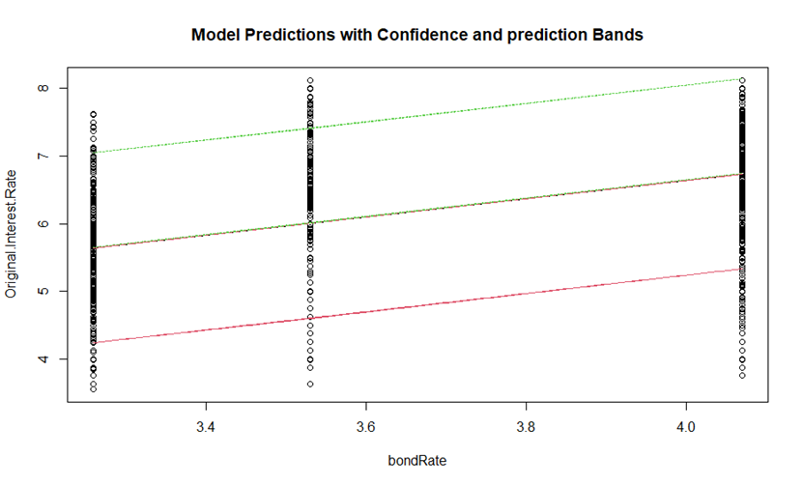

2. Predicting with Linear Model with fedFundsRate IV and Original Interest Rate DV: This model shows better prediction correlation coefficient indicating that for one unit increase in federal funds rate, there is 0.5974069 increase in Loan interest rate. Also the mean square error is smaller indicating that predicted values and actual values are closer to each other than they are for the 10 year treasury bond rate.

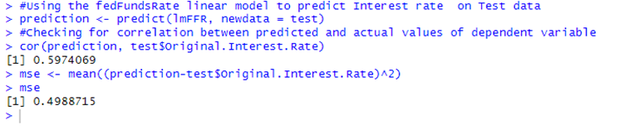

Plotting residuals: Distribution of Residuals of the model follows approximately a normal distribution but not exactly. Maybe a linear regression is not the best approximation we can get to the model for this dataset.

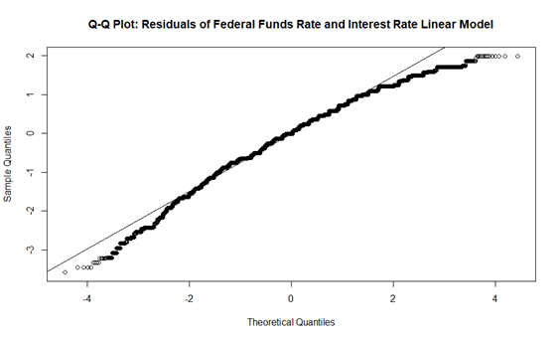

Reporting accuracy with confidence and prediction bands

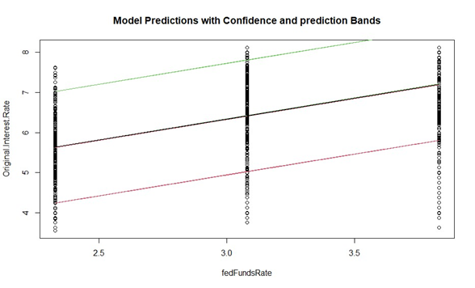

3. Predicting with Linear Model with benchMarkMortgageRate IV and Original Interest Rate DV: This model shows better prediction correlation coefficient indicating that for one unit increase in Bench Mark Mortgage rate, there is 0.5713404 increase in Loan interest rate. Also, the mean square error is 0.5225029 indicating that predicted values and actual values are closer to each other. Therefore, this model has good predictive power.

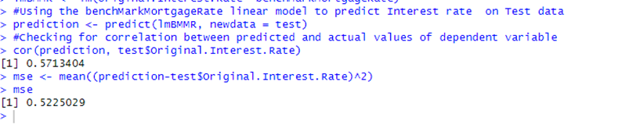

Distribution of Residuals of the model follow approximately a normal distribution but not exactly. . Maybe a linear regression is not the best approximation we can get to the model for this dataset.

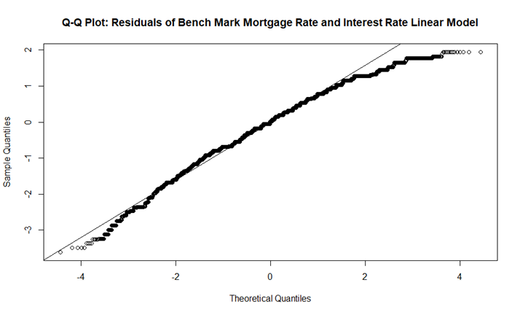

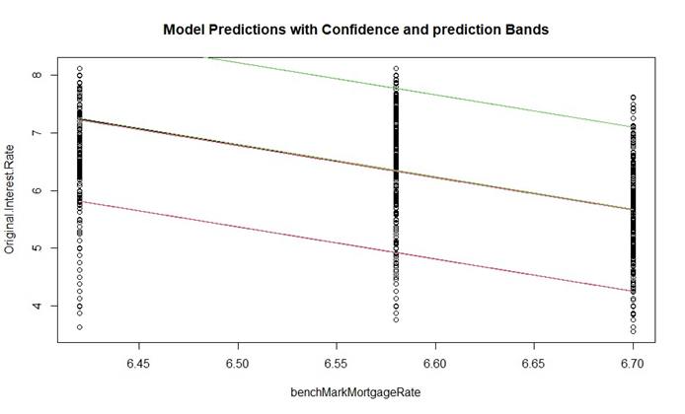

Multivariate Regression analysis, summary: Clearly the multivariate models with the new variables have better predictive power. We reproduce the important statistics of these models.

| MULTIVARIATE REGRESSION MODELS TRAINED WITH NEW TRAINING DATA SET (SORTED IN DESCENDING ORDER OF R-SQUARED VALUES) | | | | |
| --- | --- | --- | --- | --- |
| Name of Model (New dataset with 16 variables) | Coefficients of Ivs | P-val significant? | Multiple R-squared | Remarks |
| bondRate + fedFundsRate+ Borrower Credit Score + UPB+ Seller Name & Original Interest Rate | BR: 8.016e-01 FFR: 5.822e-01 CS: -2.014e-03 UPB: -5.679e-07 SN: 0.0068 to 0.68 | Yes | 0.4903 | Coefficients have magnitude and significance. R-squared can be better. Can be taken up for further analysis |
| bondRate + fedFundsRate+ Seller Name & Original Interest Rate | BR: 0.8021608 FFR: 0.5789739 SN: 0.008 to 0.68 | Yes | 0.4716 | Coefficients have magnitude and significance. R-squared can be better. Can be taken up for further analysis |
| bondRate + fedFundsRate+ Borrower Credit Score + UPB & Original Interest Rate | BR:7.826e-01 FFR: 6.502e-01 CS: 2.100e-03 UPB: -6.128e-07 | Yes | 0.4357 | Two Coefficients have magnitude and significance. Other two are very small. R-squared can be better. Model can be taken up for further analysis |
| bondRate + fedFundsRate+benchMarkMortgageRate + Borrower Credit Score+ Origination UPB & Original Interest Rate | Indeterminate for one variable | Yes | 0.4357 | We cannot train the model because of multicollinearity between fedfundsrate and benchmarkMortgageRate variables |
| bondRate + fedFundsRate+benchMarkMortgageRate + Borrower Credit Score & Original Interest Rate | Indeterminate for one variable | Yes | 0.4259 | We cannot train the model because of multicollinearity between fedfundsrate and benchmarkMortgageRate variables |
| bondRate + fedFundsRate & Original Interest Rate | BR: 0.782748 FFR: 0.651628 | Yes | 0.4194 | Coefficients have magnitude and significance. R-squared can be better. Can be taken up for further analysis |
| bondRate + Seller Name & Original Interest Rate | BR:1.293098 SN:ranging from 0.004 to 0.82 | For 20/25 levelsYes | 0.4147 | Coefficients have magnitude and significance. R-squared can be better. Can be taken up for further analysis |
| fedFundsRate+benchMarkMortgageRate & Original Interest Rate | FFR: 5.72384 BMMR: 26.41776 | Yes | 0.4142 | Coefficients have high magnitude and significance. R-squared can be better. Can be taken up for further analysis |
| bondRate + benchMarkMortgageRate & Original Interest Rate | BR: 0.883308 BMMR: -3.393897 | Yes | 0.4142 | Coefficients have magnitude and significance. R-squared can be better. Can be taken up for further analysis |
| fedFundsRate+ Seller Name & Original Interest Rate | FFR : 0.982703 SN: 0.026 to 0.672 | For 20/25 levelsYes | 0.4068 | Coefficients have magnitude and significance. R-squared can be better. Can be taken up for further analysis |
| benchMarkMortgageRate+ Seller Name & Original Interest Rate | BMMR: -5.2414617 SN: 0.008 to 0.667 | For 20/25 levelsYes | 0.3784 | Coefficients have magnitude and significance. R-squared can be better. Can be taken up for further analysis |

Divide your dataset into training and testing sets and report prediction accuracy using (1) the correlation between the predicted and real values and (2) the mean square error between the two.

For the above Models incorporating new variables, we determined the correlation and mean squared error . Clearly, the Correlation coefficients of predicted and actual values and the mean squared errors are better for these models

| LINEAR MODELS TAKEN UP FOR PREDICTING ON TEST DATA AND REPORTING ACCURACY WITH CORRELATION AND MSE | | | | | | |
| --- | --- | --- | --- | --- | --- | --- |
| Name of Model (New dataset with 16 variables) | Coefficients of Ivs | P-val significant? | Multiple R-squared | corr | mse | Remarks |
| bondRate + fedFundsRate+ Borrower Credit Score + UPB+ Seller Name & Original Interest Rate | BR: 8.016e-01 FFR: 5.822e-01 CS: -2.014e-03 UPB: -5.679e-07 SN: 0.0068 to 0.68 | Yes | 0.4903 | 0.7051072 | 0.390059 | Strong correlation between predicted and actual values of outcome variable interest rate, and low MSE indicate that the predicted and actual values converge better in this model |
| bondRate + fedFundsRate+ Seller Name & Original Interest Rate | BR: 0.8021608 FFR: 0.5789739 SN: 0.008 to 0.68 | Yes | 0.4716 | 0.6912357 | 0.405084 | Same as above |
| bondRate + fedFundsRate+ Borrower Credit Score + UPB & Original Interest Rate | BR:7.826e-01 FFR: 6.502e-01 CS: 2.100e-03 UPB: -6.128e-07 | Yes | 0.4357 | 0.6653475 | 0.43233 | Moderately strong correlation between predicted and actual values of outcome variable interest rate, and low MSE indicate that the predicted and actual values converge better in this model |
| bondRate + fedFundsRate & Original Interest Rate | BR: 0.782748 FFR: 0.651628 | Yes | 0.4194 | 0.6476303 | 0.450367 | Same as above |
| bondRate + Seller Name & Original Interest Rate | BR:1.293098 SN:ranging from 0.004 to 0.82 | For 20/25 levelsYes | 0.4147 | 0.6469263 | 0.451069 | Same as above |
| fedFundsRate+benchMarkMortgageRate & Original Interest Rate | FFR: 5.72384 BMMR: 26.41776 | Yes | 0.4142 | 0.6476303 | 0.450367 | Same as above |
| bondRate + benchMarkMortgageRate & Original Interest Rate | BR: 0.883308 BMMR: -3.393897 | Yes | 0.4142 | 0.6476303 | 0.450367 | Same as above |
| fedFundsRate+ Seller Name & Original Interest Rate | FFR : 0.982703 SN: 0.026 to 0.672 | For 20/25 levelsYes | 0.4068 | 0.642682 | 0.455321 | Same as above |
| benchMarkMortgageRate+ Seller Name & Original Interest Rate | BMMR: -5.2414617 SN: 0.008 to 0.667 | For 20/25 levelsYes | 0.3784 | 0.6199392 | 0.477593 | Same as above |

**c [3pts]** . Regularization

Repeat experiments in (a) and (b) adding regularization. Do you observe any improvements in the prediction results?

We may have too many features in our data and that is not helping our prediction model. Through regularization, we can eliminate some variables to improve our model. Regularization helps in preventing overfitting and improves generalization of linear models. There are Ridge and Lasso regularizations we can choose from with alpha parameter. When we use the library called glmnet in R, it produces another linear regression model, but with regularization.

Linear regression reveals that our variables “benchMarkMortgageRate” , “Loan Purpose” and “Number of Units, exhibit multicollinearity. Linear models could not be trained when using these variables that have perfect correlation with other independent variables such as fedFundsRate. Because of these collinearities we could not train a model on the entire dataset. We identified those variables using Pearson’s correlation and decided to remove them from the dataset. We can then train a model on the entire dataset and then use regularization techniques to remove some variables and check the improvement.

After removing these 3 variables the dimensions of our dataset is 144130 Obs of 13 variables. We then proceeded to split this dataset into training and test datasets for use in regularization.

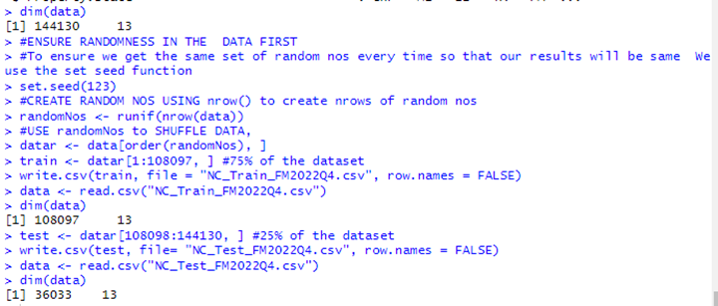

After this step, we trained a linear model on the entire training dataset to understand the coefficients of IVs and R-squared values of the model. The R-squared of the model is 0.5508 and F-statistic is 1455 on 91 and 108005 DF with p-value < 2.2e-16. Only few levels of the categorical variable Property state has significant p-values, whereas many levels of the seller name variable have significant p-values associated with the coefficients. Other than bondRate and fedFundsRate which have 0.8022 and 0.5771 magnitude coefficients, other numeric variables have much smaller coefficient magnitudes that have significant p-values for the coefficient values.

The distribution of residuals of the above linear model, does not exactly follow a Gaussian distribution. However the correlation and MSE values are the strongest among all models trained so far.

Cor between predicted and actual outcome variable vaues using test data r = 0.7429967

And mean square error of the difference between predicted and actual values mse – 0.3469728

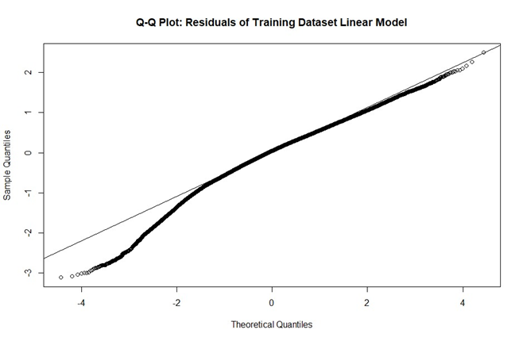

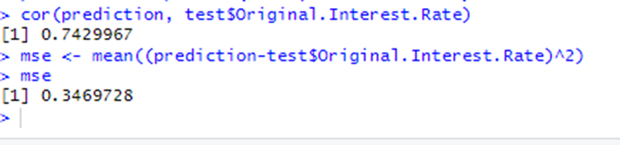

Now we proceed to learn Regularization by removing columns that have non-numeric values because regularization only works for numeric values. Therefore, we remove variables “Seller Name’, “Property Type”, “Occupancy Status” and “Property State” variables and fit a model, using the “glmnet’ function in R. We also plotted the log(lambda) values and the mean-squared error of the model and listed the coefficients for understanding which are not helping the model.

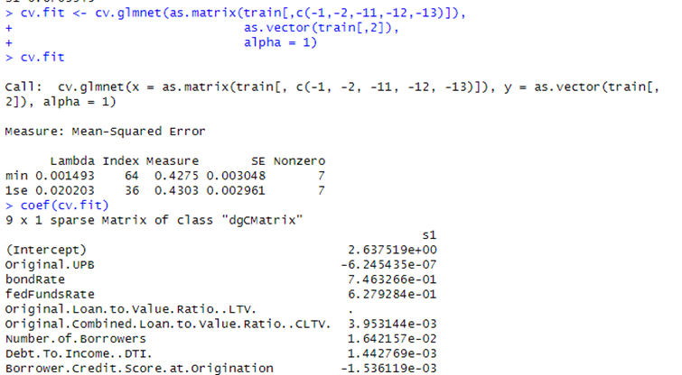

Plotting Lambda and Mean square error values:

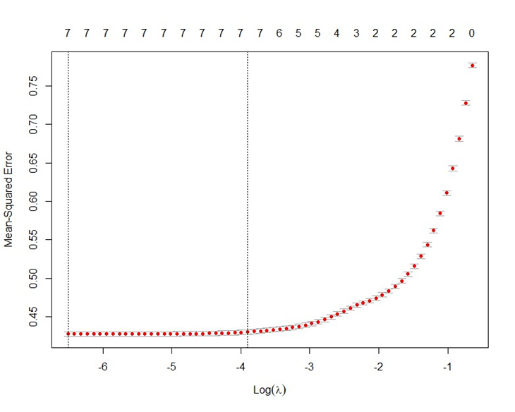

The cv.glmnet function performed cross-validation to select the optimal lambda.min value 0.001493. We used Lasso (L1) regularization by setting alpha=1. While making predictions, we provided the lambda.min value in the ‘s’ argument so that predictions are made using that value which is the optimal value.

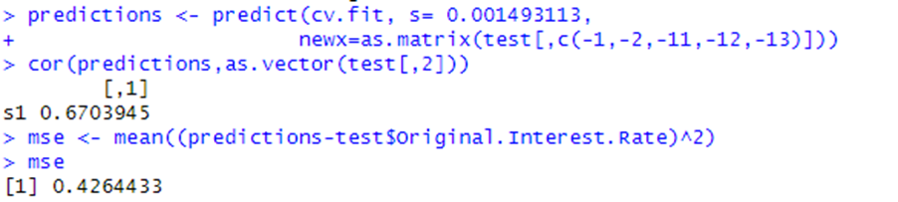

Interpretation:

1. Coefficient values: For predicting the output variable, the most important features with highest coefficients are the ‘bondRate’ variable with the highest magnitude of 0.7463266 and next the ‘fedFundsRate’ variable with a magnitude of 0.6279284. Other variables have lesser magnitudes of coefficients indicating their predictive power in predicting the outcome variable.

2. Finally with the coefficient expressed as ‘.’ , the LTV variable does not have any effect on the outcome variable according to regularization

3. *Correlation value of 0.6703945 between predicted and output values suggests that this model is not an improvement over the model without regularization.*

4. *The MSE value of 0.4264433 is also higher than the previous model without regularization. The MSE values indicate that the predicted and output values are not converging as well as in the previous model.*

**d [3pts].** Repeat a-c multiple times with different randomly selected training and testing sets and report differences or similarities across runs.

**Question 2. Logistic Regression and NB. [9 points] USHA**

**a [5pts].** With the knowledge gathered from question 1(b), compute a logistic regression model with respect to different sets of independent features on your training dataset. Remember to categorize all your variables before running the classifier. Please report:

- What is the intercept?

- What are the coefficients for each of the features? Are they statistically significant?

- What are the log-odds and odd ratios of the outcome for a unit increase in each independent variable?

Logistic regression gives us the opportunity to explore another variable as an outcome variable. The outcome variable that answers our first two research questions was ‘Original Interest Rate’, which is the loan interest rate on the ‘note’, also called the ‘Note Rate’. Since logistic regression models are linear models that output a nominal label based on a set of independent features, for this part of our analysis, we chose “Occupancy Status’ variable that has three classes or levels as the outcome variable. We used [multinomial logistic regression](https://stats.oarc.ucla.edu/r/dae/multinomial-logistic-regression/) models, with which we can classify the output into more than two classes.

*Learnings from 1(a), Stage1 with old dataset:*

1. Our Number of Units, numeric variable had only one value. A linear model could not be trained using it because of singularities.

2. Our Loan purpose categorical variable was converted to a factor to be deployed in training a model. It had singularities between levels and therefore a model could not be trained on this variable either.

3. All IVs have very small coefficients with low p-values and low R-squared values and had very limited predictive power in predicting the outcome variable, interest rate.

*Stage2: with new dataset*

4. After we infused 3 new variables named bondRate, fedFundsRate and benchMarkMortgageRate, we found that fedFundsRate and benchMarkMortgageRate had multicollinearity (r = -0.995)

5. Linear models built with new variables performed better at predicting the outcome variable.

*Learnings from 1(b) multivariate regression analysis :*

From training linear models built with each IV and DV separately on the training dataset and using them to predict the outcome variable interest rate using the ‘test’ dataset, we have learned that multivariate regression models perform better in comparison. Thereafter in answering 1(b), we trained models with different combinations of IVs and DV, to predict the outcome variable. Two models stood out. One model trained with bondRate + fedFundsRate+ Borrower Credit Score + UPB+ Seller Name as IVs & Original Interest Rate as DV, had lower coefficient values for 4 our of 5 variables but an R-squared value of 0.4903 which was the maximum value amongst all models trained. However, the same model without Seller Name had slightly better magnitudes of coefficients for the IVs with a slightly lower R-squared of 0.4357. We therefore chose this model for logistic regression.

*Learnings from 1©, Regularization:*

Also, while trying to improve our model using regularization, we understood that the LTV variable did not have any impact in predicting the outcome variable.

Here is the list of variables used for Logistic regression:

| Logistic Regression Model, IVs and DVs | | | |
| --- | --- | --- | --- |
| IVs | Type and what it means | DV | Type and what it means |
| Original Interest Rate | Numeric, Continuous, The Note rate on the Loan at the time of sanctioning the loan to the borrower | Occupancy Status | Categorical, nominal, whether the underlying property of the loan is the Primary Home of the Borrower (Class "P"), or Secondary Home of the borrower, (Class "S") or if the Property is for investment purposes "I") |
| bondRate | Numeric, discrete, 10 year Treasury Bond Yield Rate |
| fedFundsRate | Numeric, discrete, Federal Funds Rate, this is the rate at which lending institutions borrow funds overnight (Cost of funds) |
| Borrower Credit Score | Numeric, discrete, Credit Score of the borrower |
| Original UPB | Numeric, discrete, Loan quantum |

We benefited a lot from [this](https://stats.oarc.ucla.edu/r/dae/multinomial-logistic-regression/) article in performing this analysis. We created two datasets called trainLogistic and testLogistic with IVs and DV decided as per results learned from 1(b)

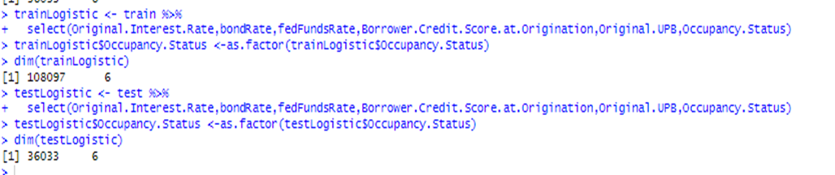

The distribution of numerical variables from the dataset

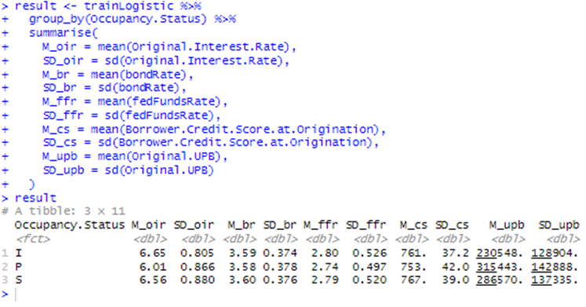

Our outcome variable Occupancy status has 3 levels. We are using the multinom() function from the nnet package in R to estimate a multinomial regression model. R chooses the first level as reference and therefore in the following output, “I” investor level is the reference level.

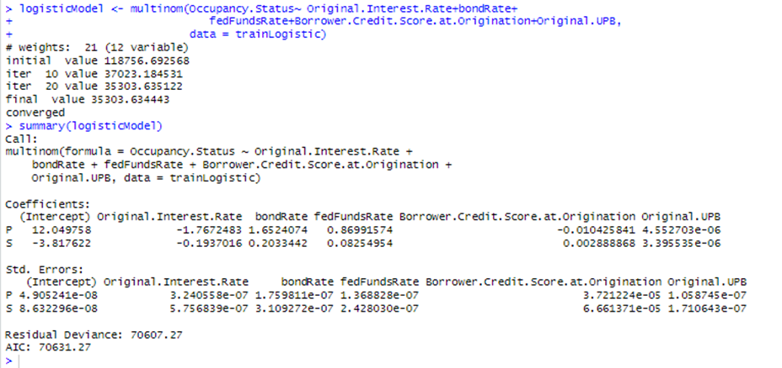

Interpretation of other results:

The output shows some iteration values and includes a final negative log-likelihood 35303.634443. This value multiplied by 2 is seen as the ‘Residual Deviance’ 70607.27. Lower values for Residual deviance and AIC indicate a better model. However, these values are not absolute and are given for comparison with the results of other models. In the table we capture the coefficients and the log odds which are explained in terms of reference level “I” for the outcome variable “Occupancy Status”.

| Levels of the DV Occupancy Status are “P”, “S” and “I”. “I” is taken as the reference level. | What is the intercept? | What are the coefficients for each of the features? | Standard Error associated with the Coefficient | Are they statistically significant? | What are the log-odds and odd ratios of the outcome for a unit increase in each independent variable? |
| --- | --- | --- | --- | --- | --- |
| P | 12.049758  This intercept represents the log-odds of being in category “P” as opposed to the reference level “I” are 12.049758 times higher. | OIR:-1.7672483    BR:1.6524074  FFR:0.86991574    CS: -0.010425841  UPB:4.552703e-06    The coefficients represent the log-odds of each category (“P” and “S”) compared to the reference category (“I”) not shown here. | OIR: 3.240558e-07    BR:1.759811e-07  FFR:1.368828e-07    CS: 3.721224e-05    UPB:1.058745e-07 | Yes. P values calculated separately using R code show they are all less than alpha(0.05) | OIR: Holding other variables constant, the Coeff estimate of -1.7672483 for this variable means that for one unit increase in this variable, the log odds of being in level “P” Vs. “I”, decrease by approximately the same number of units.(1.767)  BR: Holding other variables constant, the Coeff of 1.6524074 for this variable means that for one unit increase in this variable, the log odds of being in level “P” Vs. “I”, increase by approximately the same number of units.( 1.6524074)  FFR: Holding other variables constant, the Coeff of 0.86991574 for this variable means that for one unit increase in this variable, the log odds of being in level “P” Vs. “I”, increase by approximately the ame number of units.( 0.86991574)  CS: Holding other variables constant, the Coeff estimate of -0.010425841  for this variable means that for one unit increase in this variable, the log odds of being in level “P” Vs. “I”, decrease by approximately the same number of units.( -0.010425841)  UPB: Holding other variables constant, the Coeff estimate of 4.552703e-06  for this variable means that for one unit increase in this variable, the log odds of being in level “P” Vs. “I”, increase by approximately the same number of units.( 4.552703e-06) |
| S | -3.817622 This intercept value represents the log-odds of being in category “S" as opposed to the reference level “I” are 3.817622 times lower. | OIR: -0.1937016  BR: 0.2033442  FFR:0.08254954  CS: 0.002888868  UPB: 3.395535e-06 | OIR: 5.756839e-07      BR: 3.109272e-07  FFR: 2.428030e-07    CS: 6.661371e-05    UPB: 1.710643e-07 | Yes. . P values calculated separately using R code show they are all less than alpha(0.05) | OIR: Holding other variables constant, the Coeff estimate of -0.1937016  for this variable means that for one unit increase in this variable, the log odds of being in level “S” Vs. “I”, decrease by approximately the same number of units.( -0.1937016)  BR: Holding other variables constant, the Coeff of 0.2033442 for this variable means that for one unit increase in this variable, the log odds of being in level “S” Vs. “I”, increase by approximately the same number of units.( 0.2033442)  FFR: Holding other variables constant, the Coeff of 0.08254954  for this variable means that for one unit increase in this variable, the log odds of being in level “S” Vs. “I”, increase by approximately the same number of units.(0.08254954)  CS: Holding other variables constant, the Coeff estimate of 0.002888868  for this variable means that for one unit increase in this variable, the log odds of being in level “S” Vs. “I”, increase by approximately the same number of units (0.002888868)  UPB: Holding other variables constant, the Coeff estimate of 3.395535e-06  for this variable means that for one unit increase in this variable, the log odds of being in level “S” Vs. “I”, increase by approximately the same number of units.( 3.395535e-06  ) |

*Using Odd Ratios: We can also exponentiate coefficients and interpret everything as odd-ratios instead of log-odds which we did using R.*

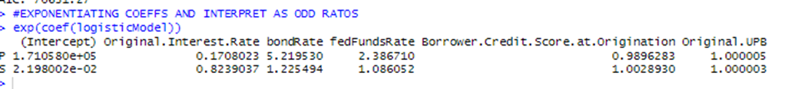

*Interpretation:*

*1.* *Intercept Values: According to this output, we can say that the odds of being in category “P” are approximately 171,058 times (intercept) higher than the reference category “I”. For “S”, the odds are 0.022 times higher than the reference category.*

*2.* *Coefficients :*

| *Name of IV* | *Coeff value of each level of Outcome variable* | *Interpretation* |
| --- | --- | --- |
| Original Interest Rate | P: 0.1708023  S: 0.8239037 | P coeff: For one unit increase in the interest rate, the odds of being in category “P” are approximately 0.1708023 times the odds of being in reference category “I”  S coeff: For one unit increase in the interest rate, the odds of being in category “S” are approximately 0.8239037times the odds of being in reference category “I” |
| bond Rate | P: 5.219530    S: 1.225494 | P coeff: For one unit increase in the interest rate, the odds of being in category “P” are approximately 5.219530 times the odds of being in reference category “I”  S coeff: For one unit increase in the interest rate, the odds of being in category “S” are approximately 1.225494times the odds of being in reference category “I” |
| *fedFundsRate* | P: 2.386710      S: 1.086052 | P coeff: For one unit increase in the interest rate, the odds of being in category “P” are approximately 2.386710 times the odds of being in reference category “I”  S coeff: For one unit increase in the interest rate, the odds of being in category “S” are approximately 1.086052 times the odds of being in reference category “I” |
| *Borrower Credit Score at Origination* | P: 0.9896283    S: 1.0028930 | P coeff: For one unit increase in the interest rate, the odds of being in category “P” are approximately 0.9896283 times the odds of being in reference category “I”  S coeff: For one unit increase in the interest rate, the odds of being in category “S” are approximately 1.0028930 times the odds of being in reference category “I” |
| *Origination UPB* | P: 1.000005      S: 1.000003 | P coeff: For one unit increase in the interest rate, the odds of being in category “P” are approximately 1.000005 times the odds of being in reference category “I”  S coeff: For one unit increase in the interest rate, the odds of being in category “S” are approximately 1.000003 times the odds of being in reference category “I” |

- Which are the most predictive features according to the training data?

According to logistic regression analysis on the training data, the coefficients of the variables Original Interest Rate, Bond Rate and Federal Funds Rate have highest magnitude and statistically significant coefficients for both “P” and “S” levels of the outcome variable. These are the most predictive features according to training data.

- Use the trained model to predict on your testing dataset. Explain your results.

We then proceeded to use the trained model to predict on testing dataset using the type = “class” argument and visualized the results using the confusion matrix. Each row in the confusion matrix displays the actual class and each column represents the predicted class.

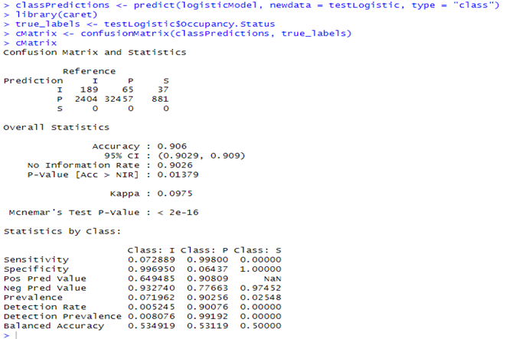

Interpretation : Our test dataset has 36033 observations. If we take the “P” class of our outcome variable, our model correctly predicted 32457 instances of the P class correctly as P class, 2404 instances from “I” class were incorrectly classified as P and 881 instances from “S” class were incorrectly classified as “P”

The overall accuracy of the model with 95% Confidence Interval is given as 0.906 which is 90.6%. The associated p-value is 0.01379 which is statistically significant.

*Sensitivity indicates the True Positive rate*: The sensitivity values for class I is 0.072889 which is very low, also for “S” which is 0. The value of “P” is high at 0.998, This indicates that the ability of the model to classify instances of “P” class is high whereas other classes is low.

*Specificity indicates the True Negative Rate*: This statistic indicates the ability of the model to correctly identify whether or not an instance belongs to a specific class. The values for specificity are high for S and I classes but low for P.

Overall, the model performs better in predicting class “P”. It performs poorly in predicting other classes “I” and “S”.

**b [4pts].** Next, we are going to report classification results using Naïve Bayes. Remember to categorize all your variables before running the classifier.

- Divide your dataset into training and testing sets and train the classifier. Report the confusion matrix.

For Naive Bayes function, we chose the same set of variables as those for Logistic regression analysis. The reason is, Naive Bayes is also a classifier like the logistic regression model and if we use the same set of variables we can compare and analyze the performance of these classifiers better.

| Naïve Bayes Model, IVs and DVs | | | |
| --- | --- | --- | --- |
| IVs | Type and what it means | DV | Type and what it means |
| Original Interest Rate | Numeric, Continuous, The Note rate on the Loan at the time of sanctioning the loan to the borrower | Occupancy Status | Categorical, nominal, whether the underlying property of the loan is the Primary Home of the Borrower (Class "P"), or Secondary Home of the borrower, (Class "S") or if the Property is for investment purposes "I") |
| bondRate | Numeric, discrete, 10 year Treasury Bond Yield Rate |
| fedFundsRate | Numeric, discrete, Federal Funds Rate, this is the rate at which lending institutions borrow funds overnight (Cost of funds) |
| Borrower Credit Score | Numeric, discrete, Credit Score of the borrower |
| Original UPB | Numeric, discrete, Loan quantum |

To train a model using Naïve Bayes classifier, we started with our New_FM2022Q4.csv dataset. We used the sample function to split our dataset into test and training sets and filtered out un predictive variables.

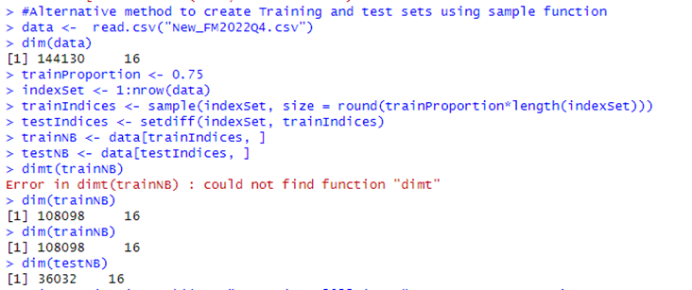

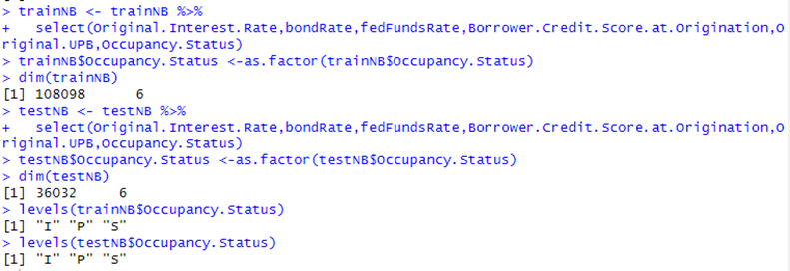

Training our model using Naïve Bayes function: The naiveBayes function calculates the A-priori probabilities and conditional probabilities for different classes in the outcome variable. We can use the conditional probabilities calculated to make predictions on test data and calculate accuracy of the model. Since we need to analyze the improvement in predictions with and without Laplace estimator, we have specified the laplace = 0 argument in our model in the training phase to train the model without the estimator and record the results.

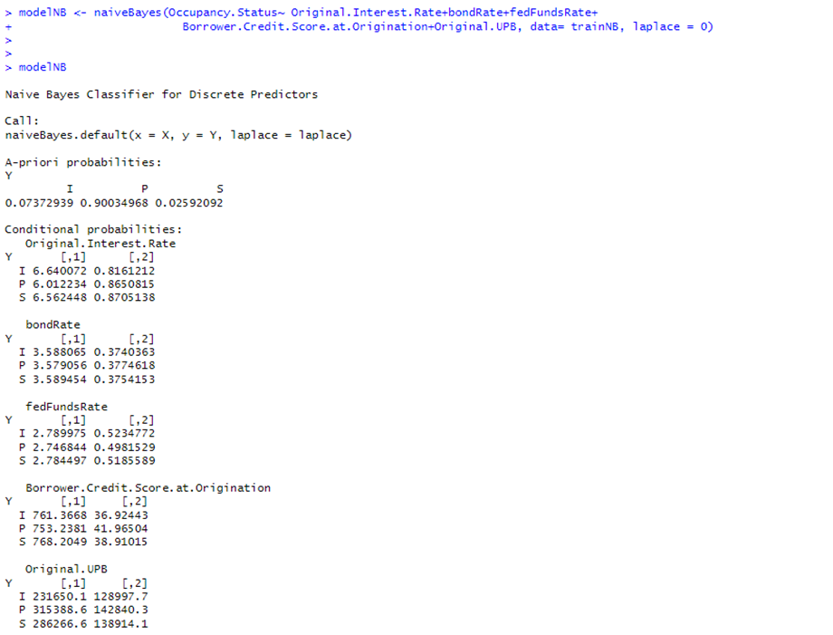

Interpretation : Since our predictor variables are numeric, the model displays the values of Mean and SD of the probability distributions as under.

| CLASS | A-priori probabilities | Conditional Probabilities | | | | | | | | | |
| --- | --- | --- | --- | --- | --- | --- | --- | --- | --- | --- | --- |
| Original Interest Rate | | bondRate | | fedFundsRate |  | Credit Score |  | UPB | |
|  |  | Mean | SD | Mean | SD | Mean | SD | Mean | SD | Mean | SD |
| I | 0.07373 | 6.6401 | 0.816121 | 3.588065 | 0.374036 | 2.789975 | 0.523477 | 761.3668 | 36.92443 | 231650.1 | 128997.7 |
| P | 0.90035 | 6.0122 | 0.865082 | 3.579056 | 0.377462 | 2.746844 | 0.498153 | 753.2381 | 41.96504 | 315388.6 | 142840.3 |
| S | 0.02592 | 6.5624 | 0.870514 | 3.589454 | 0.375415 | 2.784497 | 0.518559 | 768.2049 | 38.91015 | 286266.6 | 138914.1 |

Making predictions with the above model trained without laplace estimator

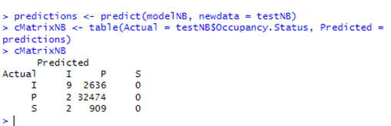

Interpretation: For the class I, our model without the Laplace smoothing, has correctly predicted only 9 instances as I and incorrectly predicted 2636 instances as ‘P”. For ‘P” the model correctly predicted 32474 instances as P but incorrectly predicted two instances as I. For the class S, the model incorrectly predicted 909 instances as P. If we compare this output with the logistic regression output, we find that both these classifiers are better at predicting the class “P” than other two classes.

- Repeat the process above with the Laplace estimator. Do the results improve?

Laplace estimator is used with value ‘0’ or ‘1’ in the naïve bayes function, at the time of training the model. This is called Laplace smoothing and involves adding a small constant usually 1, to each count of events to ensure that no probability becomes zero. Here we have trained our model using laplace =1

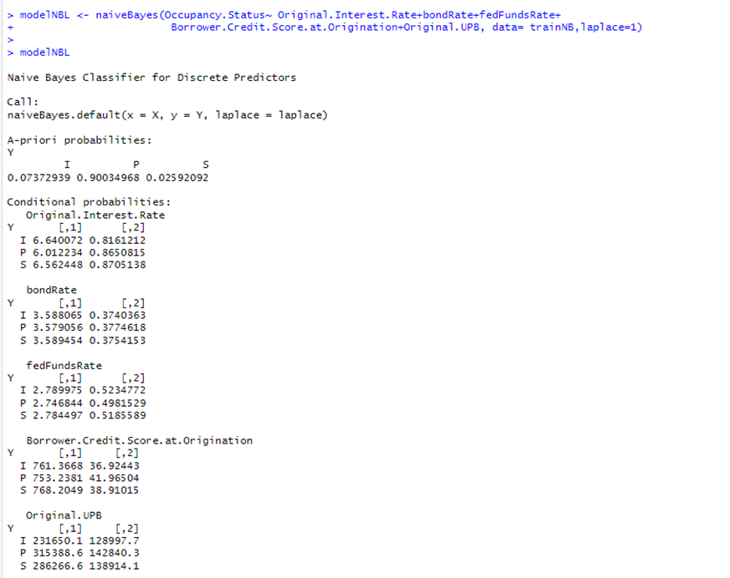

The predictions and confusion matrix are :

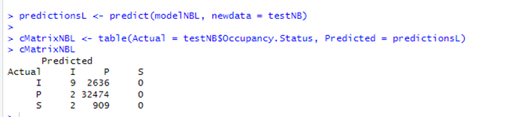

Interpretation : There is no improvement in the performance of the model with Laplace smoothing. Basically, the confusion matrix shows identical numbers for both the models with or without laplace estimator. We can say that the model primarily predicted class ‘P” for all instances of test data and did not predict the remaining two classes.

Reason for under performance of the model: Naïve Bayes assumes independence between predictor variables. But three of our predictor variables have high degree of correlation as explained by pearson’s coefficient here. We can see that the underlying assumption of independence between predictor variables is violated in the dataset we used.

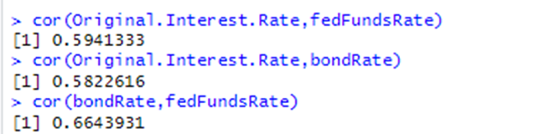

**Question 3. Decision Trees and Random Forests.[11] USHA**

In this question we will evaluate the efficacy of decision trees and random forests. If your problem is multi-class (not binary), you will need to use all the classes to test the accuracy. If your independent variable is continuous, divide it into ranges between min and max values and consider each range a class.

**a [2pts].** Split your dataset into training and testing sets assuming that samples are not randomly ordered (Hint: generate random numbers). Show that the distribution after the split is similar to the original.

We split the data using random numbers into training and test datasets. The dimensions of our dataset are before split : 144130 obs of 16 variables. Training dataset: 108098 obs of 16 variables. Test Dataset : 36032 obs of 16 variables

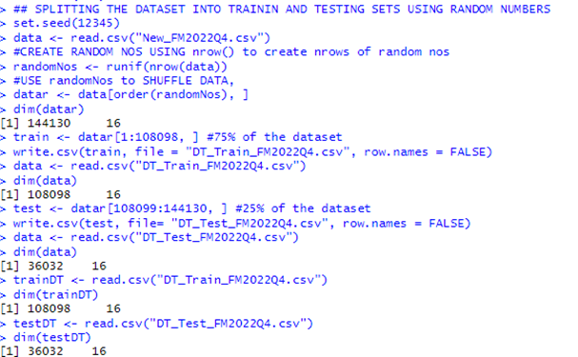

We used the R summary() function to verify if the distributions are similar.

Distribution of Dataset before split

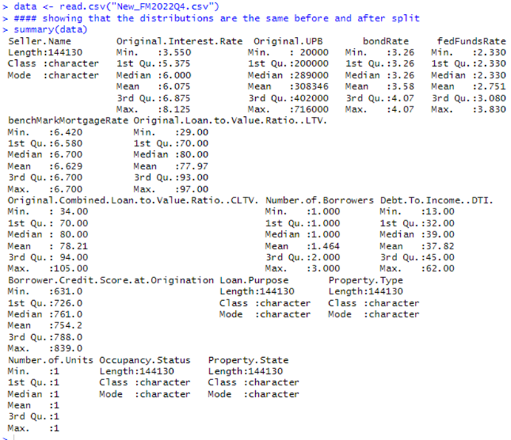

Distribution of Training Dataset

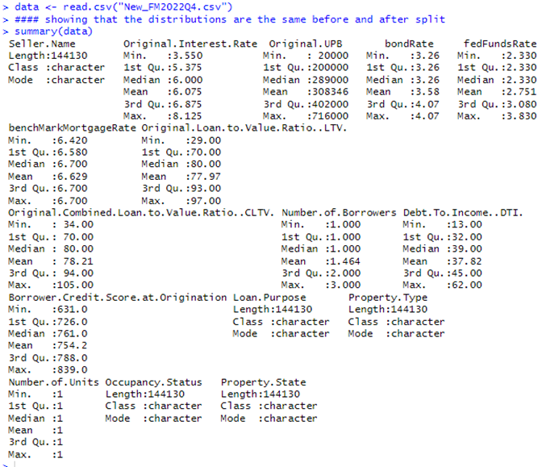

Distribution of Test Dataset

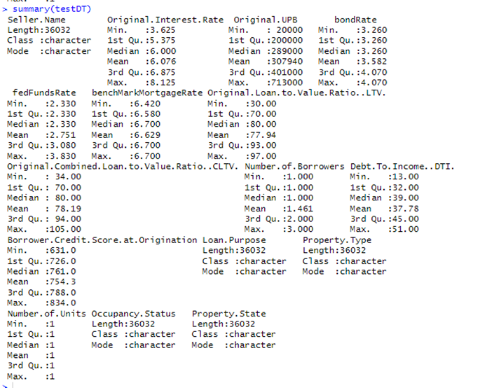

Interpretation : The distribution of the datasets are similar.

**b [3pts]** . Train a decision tree and interpret the main resulting if-then rules (together with their corresponding plots).

We decided to use the same IVs and DV that we used in Logistic regression and Naïve Bayes function for the Decision Tree model also so as to be able to compare the performance of these classifiers on the same set of variables.

| Decision Tree Model, IVs and DVs | | | |
| --- | --- | --- | --- |
| IVs | Type and what it means | DV | Type and what it means |
| Original Interest Rate | Numeric, Continuous, The Note rate on the Loan at the time of sanctioning the loan to the borrower | Occupancy Status | Categorical, nominal, whether the underlying property of the loan is the Primary Home of the Borrower (Class "P"), or Secondary Home of the borrower, (Class "S") or if the Property is for investment purposes "I") |
| bondRate | Numeric, discrete, 10 year Treasury Bond Yield Rate |
| fedFundsRate | Numeric, discrete, Federal Funds Rate, this is the rate at which lending institutions borrow funds overnight (Cost of funds) |
| Borrower Credit Score | Numeric, discrete, Credit Score of the borrower |
| Original UPB | Numeric, discrete, Loan quantum |

We trained the Decision Tree over the training dataset using the C5.0() function in R.

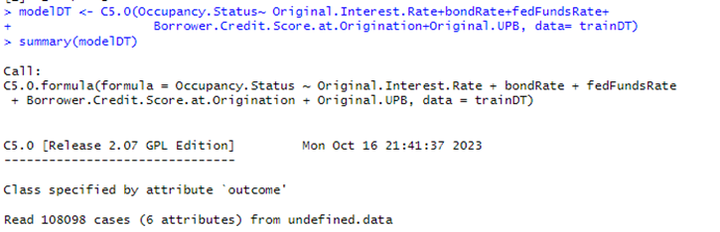

These are our main if-then rules of the Decision Tree model.

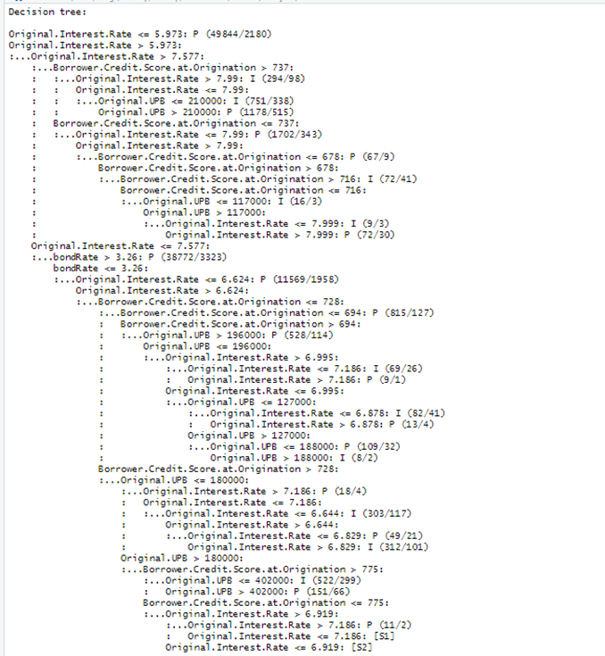

Test the trained tree with your testing dataset and compare the confusion matrices obtained during training and testing: compute percentages of correctly and incorrectly classified samples and compare results in training and testing.

**c [3pts].** Apply boosting with different numbers of trees and analyze the impact on the prediction results: what is the impact of the number of trees in the accuracy of the classifier?

**d [3pts].** Do the same analysis with bagging and random forests: train with bagging and then train with random forests using at least four different numbers of trees. Compare prediction results over the testing sets. Which are the most important features in each random forest?

**Question 4. Comparative Analysis.[5] TANYA**

**[5 pts]** Write a summary of all classifiers, their predictive quality and which one would you use to answer your research question(s).